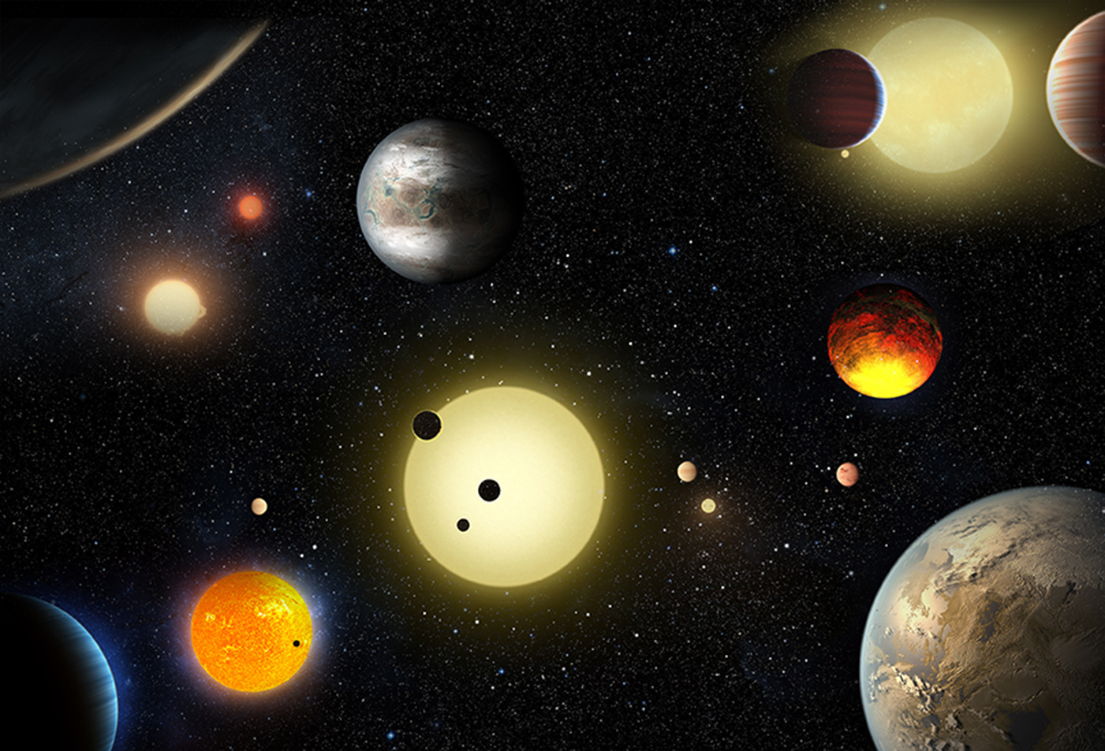
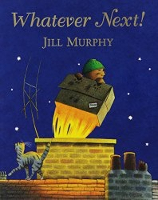
Starry Night!
Pedrevan Class
Spring 1 2022
Physical Development
Children will be…
- Climbing and balancing in the park.
- Playing on the bikes and scooters.
- Learning new skills within PE!
- Enjoying weekly themed yoga sessions with Cosmic Kids videos.
- Developing and mastering cutting skills.
- Practising accurate pencil control for neat handwriting.

Personal, Social and Emotional Development
Children will be…
- Explaining own knowledge and understanding.
- Take steps to resolve conflicts, negotiate and resolve problems.
- Understand and follow more complex instructions.

Literacy
Children will be…
- Using phonic knowledge to read and write simple sentences.
- Identifying and spelling ‘red’ words when reading and writing.
- Learning the key features of sentence writing, e.g; starting with a capital letter, using finger spaces between words and ending with a full stop.
- Sequencing and re-telling our class story ‘Whatever Next!’ as well as looking at information books about our Space topic.
- Writing for different purposes, related to ‘Whatever Next!’ and our Space topic, such as; writing labels and captions, speech bubbles, lists and instructions.

Understanding the World
Children will be…
- Learning why we have night and day.
- Finding out about people who work at night.
- Learning about nocturnal animals.
- Naming and ordering the planets in our Solar System and finding out information about them.

Expressive Arts and Design
Children will be…
- Learning to make lighter and darker shades of the primary colours using paint.
- Developing and mastering different joining and assembling techniques.
- Creating paintings in the style of Picasso.
- Designing and making their own space craft using junk modelling.
Communication and Language
Children will be…
- Learning the story “Whatever Next!”
- Retelling and sequencing the story using stick puppets and story maps.
- Listening carefully to and discussing facts about our Space topic.
- Asking and answering questions.
- Learning new topic-based vocabulary.

Mathematics
Children will be…
- Developing mastery of numbers up to 10 through…
- Counting.
- Subitising (saying how many without counting)
- Composing and decomposing.
- Comparing and ordering.
- Adding and subtracting.

Mathematics
Children will be…
- Counting, reading, writing and ordering numbers to 20 and beyond.
- Matching numerals to quantities.
- Adding by finding the total of 2 sets.
- Recognising and counting coins.
- Making and describing repeating patterns.
- Comparing and ordering objects by height and weight.

