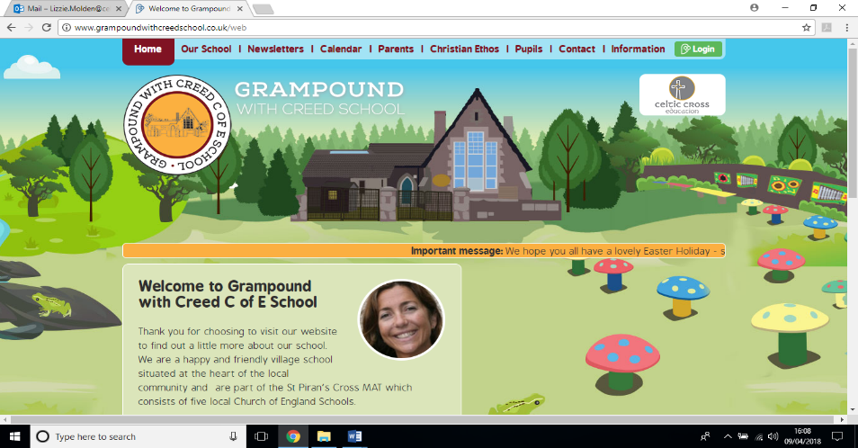

**How is Kenya different to the UK?**

**Lostledan Class**

**Essential Knowledge**

By the end of this unit the children will know…

* How Kenya compares to the UK.
* What a balanced diet consists of.
* Who the Maasai people are.
* How to create a shoebox safari.
* Why it is important to care for people around the world.
* How to play a djembe drum.
* How to categorise animals.
* What landscapes Kenya is made up of.

**Launch**

**What is Kenyan cuisine like?**

The children will be immersed in cooking activity, creating a healthy rice and vegetable dish!

We will also create Kenyan flags from different coloured lentils.

Throughout this week, the children will use map skills to locate Kenya and consider how poverty affects some of the Kenyan people.

**Explore**

**Life in Kenya**

Pupils will engage in a range of mini Geography and Art projects, based on Kenya and what it is like there.

The children will compare this incredible African country with our own, thinking about differences in weather, houses and school life!

We will learn the story of Handa’s Surprise and use footage from The Lion King to inspire our writing.

**Energise**

**Christmas**

Project Week:

During the second half of the term, pupils will focus on how Christians celebrate Christmas; looking at the story of the Nativity and taking part in a variety of D.T. and Art projects.

**Celebrate**

**Porfell Wildlife Park and Sanctuary**

We will be visiting Porfell Wildlife Park and Sanctuary to celebrate our learning!

We will have the opportunity to observe some of the animals that are native to Kenya!

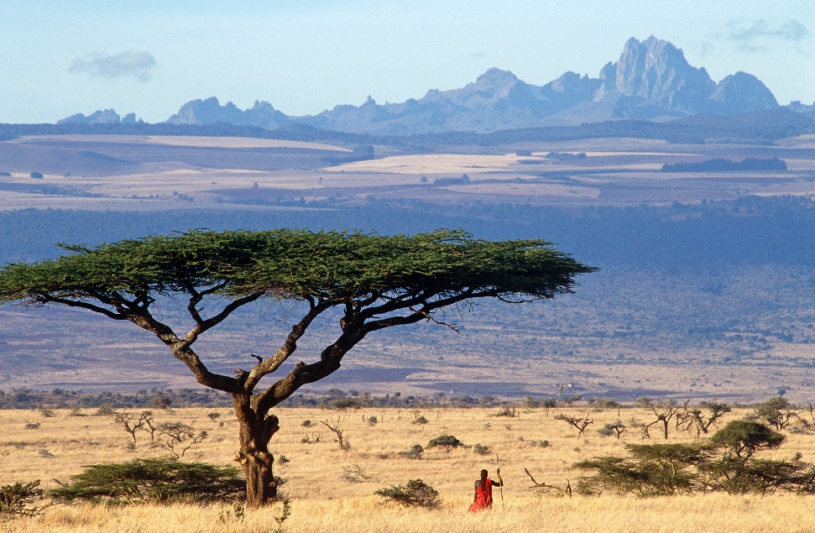



**Art and Design & Design and Technology**

* Create a Kenyan flag using lentils.
* Paint and decorate a Maasai mask.
* Use oil pastels to draw the face of a lion.
* Experiment with tasting exotic fruits.
* Design and create a healthy rice dish.
* Design and create a shoebox safari.

**Mathematics**

**Number – Addition and Subtraction**

* Children to use a range of apparatus and visual methods to add and subtract.

**Measurement – Length and Height**

* Children to use a range of measuring tools to measure, compare and order lengths and heights.

**Geometry – Properties of Shapes**

* Children to be confident in naming 2D shapes and identifying their properties.

**Writing**

* Write a letter to a Kenyan schoolchild.
* Write descriptions for different fruits.
* Compose poetry based on mountains.
* Write a descriptive piece of writing based on The Lion King.
* Compose a recount about a school trip.
* Write a non-chronological report about a safari animal.

**History & Geography**

* Learn about the Maasai people and their traditions.
* Compare the lives of Kenyan people with our own.
* Discuss how markets provide some Kenyan people with a job.
* Research information about Mount Kenya.
* Compare Nairobi with London.
* Use mapping skills to discover where Kenya is in the world.

**How is Kenya different to the UK? – Theme Content**

**Core Subjects**

**Personal Development**

**Foundation Subjects**

**Cultural**

* How is the life of a Kenyan child different to ours?
* Why is it important to learn about others’ lives?

**Social**

* Welcome new members to the class, ensuring positive relationships are established.
* Consider how best to work as a team for the benefit of our learning.

**Moral**

* Why is it important to consider the lives of others around the world?
* What do we understand about endangered species and how to protect these animals?

**Computing**

* Use the internet to research information about animals native to Africa.
* Use PowerPoint to share information about African mountains.

**Spiritual**

* Christianity – What is the nativity story? Why is this story important to Christians around the world? How do you celebrate Christmas?

**Music & Physical Education**

* Appreciate music and singing from other cultures.
* Use percussion instruments to compose a piece of African music.
* Experience African dancing and perform to a small audience.
* Partake in the ‘Daily Mile’ as a way of helping with our health and wellbeing.

**Science**

* Consider what a balanced diet consists of.
* Participate in an experiment to create a ‘volcanic eruption’.
* Think about the life cycle and growing up.
* Research information about a range of animals and begin to classify them correctly.



**How is Kenya different to the UK? – Links to National Curriculum**

**Core Subjects**

**Foundation Subjects**

**Writing**

* Composing a sentence orally before writing it. (Year 1)
* Writing narratives about personal experiences and those of others (real and fictional). (Year 2)
* Composing and rehearsing sentences orally (including dialogue), progressively building a varied and rich vocabulary and an increasing range of sentence structures. (Year 3)

**Mathematics**

* Read, write and interpret mathematical statements involving addition (+), subtraction (–) and equals (=) signs. (Year 1)
* Compare and order lengths, mass, volume/capacity and record the results using >, < and =. (Year 2)
* Identify horizontal and vertical lines and pairs of perpendicular and parallel lines. (Year 3)

**Science**

* Identify and name a variety of common animals including fish, amphibians, reptiles, birds and mammals. (Year 1)
* Identify and name a variety of plants and animals in their habitats, including microhabitats. (Year 2)
* Identify that animals, including humans, need the right types and amount of nutrition, and that they cannot make their own food; they get nutrition from what they eat. (Year 3)

**History & Geography**

* Understand geographical similarities and differences through studying the human and physical geography of a small area of the United Kingdom, and of a small area in a contrasting non-European country. (KS1)
* Use basic geographical vocabulary to refer to: physical features, including: beach, cliff, coast, forest, hill, mountain, sea, ocean, river, soil, valley, vegetation, season and weather and key human features, including: city, town, village, factory, farm, house, office, port, harbour and shop. (KS1)
* Physical geography, including: climate zones, biomes and vegetation belts, rivers, mountains, volcanoes and earthquakes, and the water cycle. (KS2)

**Art and Design & Design and Technology**

* To use a range of materials creatively to design and make products. (KS1)
* To improve their mastery of art and design techniques, including drawing, painting and sculpture with a range of materials [for example, pencil, charcoal, paint, clay]. (KS2)
* Use the basic principles of a healthy and varied diet to prepare dishes. (KS1)
* Select from and use a wider range of materials and components, including construction materials, textiles and ingredients, according to their functional properties and aesthetic qualities. (KS2)

**Music & Physical Education**

* Play tuned and untuned instruments musically. (KS1)
* Appreciate and understand a wide range of high-quality live and recorded music drawn from different traditions and from great composers and musicians. (KS2)
* Perform dances using simple movement patterns. (KS1)
* Perform dances using a range of movement patterns. (KS2)

**Computing**

* Use technology purposefully to create, organise, store, manipulate and retrieve digital content. (KS1)
* Understand computer networks including the internet; how they can provide multiple services, such as the world wide web; and the opportunities they offer for communication and collaboration. (KS2)