National Curriculum 2014 Planning Document
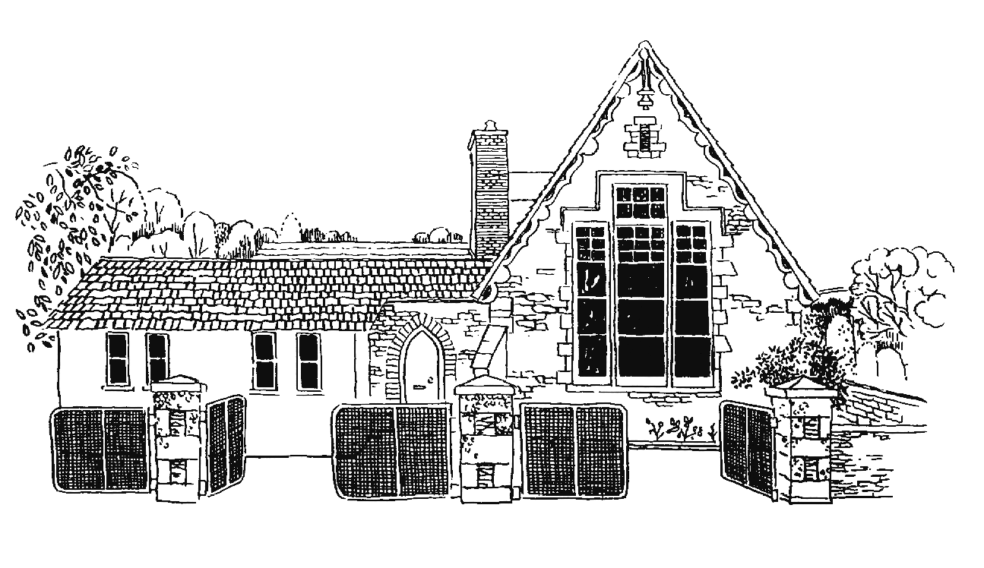
Grampound with Creed School
Y3
Vocabulary, Grammar and Punctuation Appendix
This document contains the Y3 Vocabulary, Grammar and Punctuation appendix and should be used to support the planning, teaching and learning of Spelling in Year 3.

Year 3: Detail of content to be introduced (statutory requirement)
Word | Formation of nouns using a range of prefixes [for example super–, anti–, auto–]  Use of the forms a or an according to whether the next word begins with a consonant or a vowel [for example, a rock, an open box]  Word families based on common words, showing how words are related in form and meaning [for example, solve, solution, solver, dissolve, insoluble]
Sentence | Expressing time, place and cause using conjunctions [for example, when, before, after, while, so, because], adverbs [for example, then, next, soon, therefore], or prepositions [for example, before, after, during, in, because of]
Text | Introduction to paragraphs as a way to group related material  Headings and sub-headings to aid presentation  Use of the present perfect form of verbs instead of the simple past [for example, He has gone out to play contrasted with He went out to play]
Punctuation | Introduction to inverted commas to punctuate direct speech
Terminology for pupils | preposition conjunction  word family, prefix  clause, subordinate clause  direct speech  consonant, consonant letter vowel, vowel letter  inverted commas (or ‘speech marks’)

