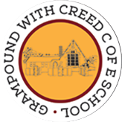
Grampound with Creed School - EYFS – Knowledge Organiser

 |  |  |  |  |  | Christmas
 | Key Vocabulary |  |  |  |  | Key Learning  - Every year on 25th December, Christians celebrate the day Jesus was born, about 2,000 years ago.  - Jesus is the most important person in the Nativity story.  - Christians believe that God came to Earth in human form as Jesus.  - Christians believe Jesus came to show that all people are precious and special to God.  - The bible is a special book to Christians, it tells us the story of Jesus’s birth and other stories about him when he was an adult.  - All adults were babies once.  - Advent is the count down to Christmas and begins on the 1st December.  - Christmas is celebrated in many ways, many of which have become traditions for all Christians, such as hanging decorations, decorating a Christmas tree and hanging stockings for Father Christmas to fill with presents.  - It is a tradition to give presents and cards to friends, family and the community at Christmas.  - Christmas is a holiday time and it is tradition to spend time with family and friends over the holiday period.
 | Tier 1  A long time ago  Now  God  Stable  Journey  Baby  Tree  King  Angel  Star  Reindeer  Stocking  Decorations  Camel  Donkey | Tier 2  Manger  Important  Travelled  Precious/special  Celebrate  Tradition | Tier 3  Christians  Jesus  Joseph  Mary  Christmas  Nativity  Bethlehem  Inn keeper Tinsel/baubles  Donkey Father Christmas  North Pole
 | Key Texts  The Nativity Story |  |  |  |  | Key songs/rhymes  - Christmas carols  - Songs from school Nativity |  | Online resources  - Cbeebies/watch/something-special-happy-birthday  - Cbeebies Topsy and Tim – “Birthday Party”  - Peppa Pig – “My birthday Party” - YouTube
 |  |  |  |  |  | Key Themes
 | The First Christmas |  |  |  |  |  | Christmas celebrations | Who was Jesus?
 | 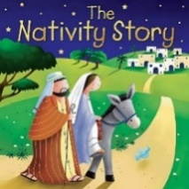 |  |  |  |  |  |  | 