 |  |  |  |  |  | Starry Night
 | Key Vocabulary |  |  |  |  | Key Learning  - Dark is caused by the absence of light.  - It is dark at night because the Earth is facing away from the sun.  - During the day it is light because the Earth is facing the sun.  - The moon and stars are always in the sky but the sun’s bright light hides them in the daytime.  - The moon can normally be seen in the night sky.  - The moon orbits the Earth.  - People have visited the moon.  - People travel into space in space shuttles.  - The names and order of planets in our solar system.  - Facts about each planet in the solar system.  - There are adults in our community who work at night to help us.  - Nocturnal animals are awake during the night and asleep in the day.  - A good bedtime routine is important to health and wellbeing.  - Brushing teeth twice a day and avoiding sugary drinks and snacks helps keep teeth healthy.  - Paint can be made lighter and darker to create different shades of the same colour.
 | Tier 1  A long time ago  Dark/light  Night/day  Moon  Stars  Sky  Space  Owl  Fox  Bat  Badger | Tier 2  Primary  Shades  Lighter  Darker  Away  Towards  Gas  Ice  Telescope  Healthy  Sugary | Tier 3  Nocturnal  Solar system  Earth  Planets  Planet names  Space shuttle  Satellite  Astronaut  Apollo  Orbit  Comet/asteroid  Craters
 | Key Texts  - Whatever Next! |  |  |  |  | Key songs/rhymes  - 5 Little Men in a flying saucer | Online resources  - YouTube – moon landing clips  - YouTube – solar system video
 |  |  |  |  |  | Key Themes
 | Day and Night (Light and Dark) |  |  |  |  | People who work at night  Nocturnal animals |  | The Solar System
 | 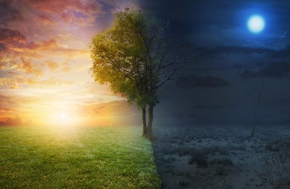 |  |  |  |  | 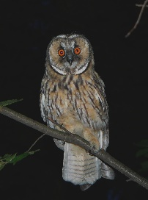  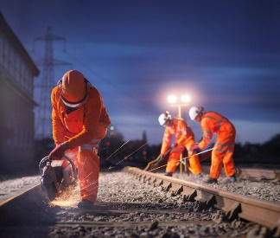 |  | 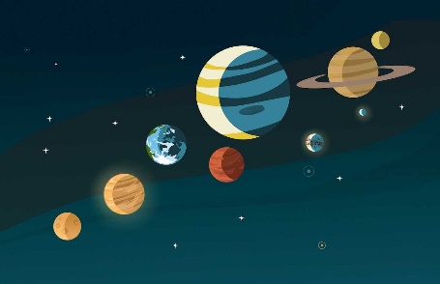
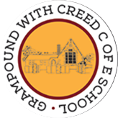
Grampound with Creed School - EYFS – Knowledge Organiser

