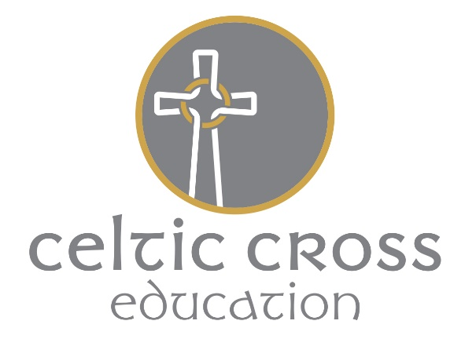

Grampo G Grampound with Creed C of E Primary School
Early Years Foundation Stage Policy 2021-2022
Rationale
‘Every child deserves the best possible start in life and the support that enables them to fulfil their potential.’
Statutory framework for the early years foundation stage pg5 (September 2021)
The following documents should be read in conjunction with this policy: Admissions Policy, Health and Safety Policy, Safeguarding, Equal Opportunities Policy; Inclusion Policy; Behaviour Policy.
Aim
We aim to provide:
- The highest quality care and education for all our children thereby giving them a strong foundation for their future learning.
- A safe and happy environment with motivating and enjoyable learning experiences that meet the learning and development needs of each individual child, enabling them to become confident and successful life-long learners.
- Effective partnership working between practitioners and parents/carers, to ensure that every child’s needs are met and every child is given the opportunity to reach their full potential.
We recognise the EYFS as a distinct and important phase in every child’s early education:
‘Children develop quickly in the early years and a child's experiences between birth and age five have a major impact on their future life chances.’ Statutory framework for the early years foundation stage pg5 (September 2021)
We adhere to the Statutory EYFS Framework 2021 and the four guiding principles that shape practice within all Early Years settings….
• Every child is a unique child, who is constantly learning and can be resilient, capable, confident and self-assured.
• Children learn to be strong and independent through positive relationships.
• Children learn and develop well in enabling environments with teaching and support from adults, who respond to their individual needs and help them to build their learning over time. Children benefit from a strong partnership between practitioners and parents/carer.
• Importance of learning and development. Children develop and learn at different rates.
Principles into Practice
As part of our practice we:
• Promote equality of opportunity and anti-discriminatory practice;
• Work in partnership with parents, and/or carers, and within the wider context;
• Provide early intervention for those children who require additional support;
• Provide a range of activities and experiences, based on the seven areas of learning and development.

The Foundation Stage Curriculum
We plan a broad and balanced curriculum, based on the seven areas of learning, supported by the Maestro Cornerstones Curriculum and our own Skills Development Plan.
Activities and experiences are provided in response to our observation of children’s needs, interests, and stages of development.
We create a stimulating environment providing opportunities for children to ‘free-flow’ between the inside and outdoor environment.
Our practise is under-pinned by the Characteristics of Effective Learning (COEL):
- Playing and exploring – children investigate and explore things, and ‘have a go’.
- Active learning – children concentrate and keep on trying if they encounter difficulties and enjoy achievements.
- Creating and thinking critically – children have and develop their own ideas, make links between ideas, and develop strategies for doing things.
Statutory framework for the early years foundation stage pg16 (September 2021)
We provide daily opportunities for children to engage with a range of meaningful and challenging first-hand experiences, in which they can explore, think creatively and be actively involved in. Through such activities, we aim to develop and foster children’s; confidence, independence and resilience. Many of these skills are developed in the outdoors, which children access for sustained periods of free play on a daily basis, including; fields, gardens, play park and a woodland play area.
We recognise that the three prime areas are particularly crucial for igniting children's curiosity and enthusiasm for learning, and for building their capacity to learn, form relationships and thrive.
These areas reflect the key skills and capacities all children need to develop and learn effectively and become ready for future learning…
- Communication and Language
- Personal, Social and Emotional Development
- Physical Development
Children are also supported in the four specific areas…
- Literacy
-Maths
-Understanding the World
-Expressive Arts and Design
Children learn through a balance of child-initiated and adult-directed sessions;
• Child initiated sessions – Activities and resources provided in the enhanced provision are purposefully planned to support; progressive skills development. They also reflect or current topics and promote the Prime areas of learning. Activities and resources are also provided in response to the changing interests and needs of the children.
• Adult Directed Sessions – Read Write Inc Phonics, Maths Mastery, guided writing sessions, PE (planned and delivered by a specialist PE teacher), topic, RE and PSHE lessons, daily stories and singing sessions.

Observation and Assessment
We understand that assessment plays an important part in helping practitioners and parents and carers to recognise children’s progress, understand their needs, and to plan activities and intervention. As part of our daily practice we constantly observe and assess children’s development and learning to identify and better understand their level of achievement, interests and learning styles, and to shape and inform their next steps.
Significant moments in children’s learning and development are photographed and shared with parents immediately on Class Dojo so that achievements can be formally recognised and celebrated.
In, the final term of the year in which the pupil reaches age five, and no later than 30th June in that term, the EYFS profile is completed for each child, providing parents and carers, practitioners and teachers with a well-rounded picture of the child’s knowledge, understanding and abilities, their progress against expected levels and their readiness for Year one. The Profile reflects: ongoing observations, records held by the school, discussions with parents and carers, and any other relevant information provided by other agencies.
Safety
Children’s safety and welfare is paramount. We create a safe and secure environment, and provide a curriculum, which teaches children how to be safe, make choices and assess risks. We have stringent policies, procedures and documents in place to ensure children’s safety.
We promote the good health of the children in our care in numerous ways, including the provision of nutritious food, following set procedures when children become ill or have an accident. Please see our separate policies and procedures on Health and Safety, Child Protection; Healthy Schools, Medical issues.
Inclusion
We value all our children as individuals, irrespective of their ethnicity, culture, religion, home language, background, ability or gender. We plan a curriculum that meets the needs of the individual child and supports them at their own pace to give them the best opportunity to achieve the Early Learning Goals. We strongly believe that early identification of children with additional needs is crucial in enabling us to give children the support that they need. Throughout this process we work closely with parents, our SENCO and outside agencies as necessary. See our separate policies on Equality of Opportunity and Learning Support.
Parents as Partners and the wider context
We strive to create and maintain close partnership with parents and carers. We recognise that together, we can have a significant impact on a child’s learning. We welcome and actively encourage parents to participate in their child’s education and care in numerous ways., for example through their child’s reading record books and use of Class Dojo.
We encourage parents and carers to add and respond to observations on Class Dojo, as often as possible. Dojo is also used as a messaging service directly between practitioners and parents which strengthens regular two-way communication between home and school.
In the Autumn and Spring terms, parents are invited to attend parent’s evenings to discuss their child’s wellbeing and progress. Also, in the Autumn tern, we invite parents in to the classroom to observe a phonics session (Covid restrictions allowing). In the Summer term, we provide parents with a report showing their child's level of development against each of the Early Learning Goals and the characteristics of their learning. Parents are given the opportunity to discuss their child’s judgements and next steps with the EYFS teacher in preparation for Year One.
Our aim is to build trusted relationships with parents and carers, through which we can work together to ensure that every child is given the best opportunity to reach their full potential and develop a positive attitude towards learning.
Date of review September 2021

Date of next review September 2023

