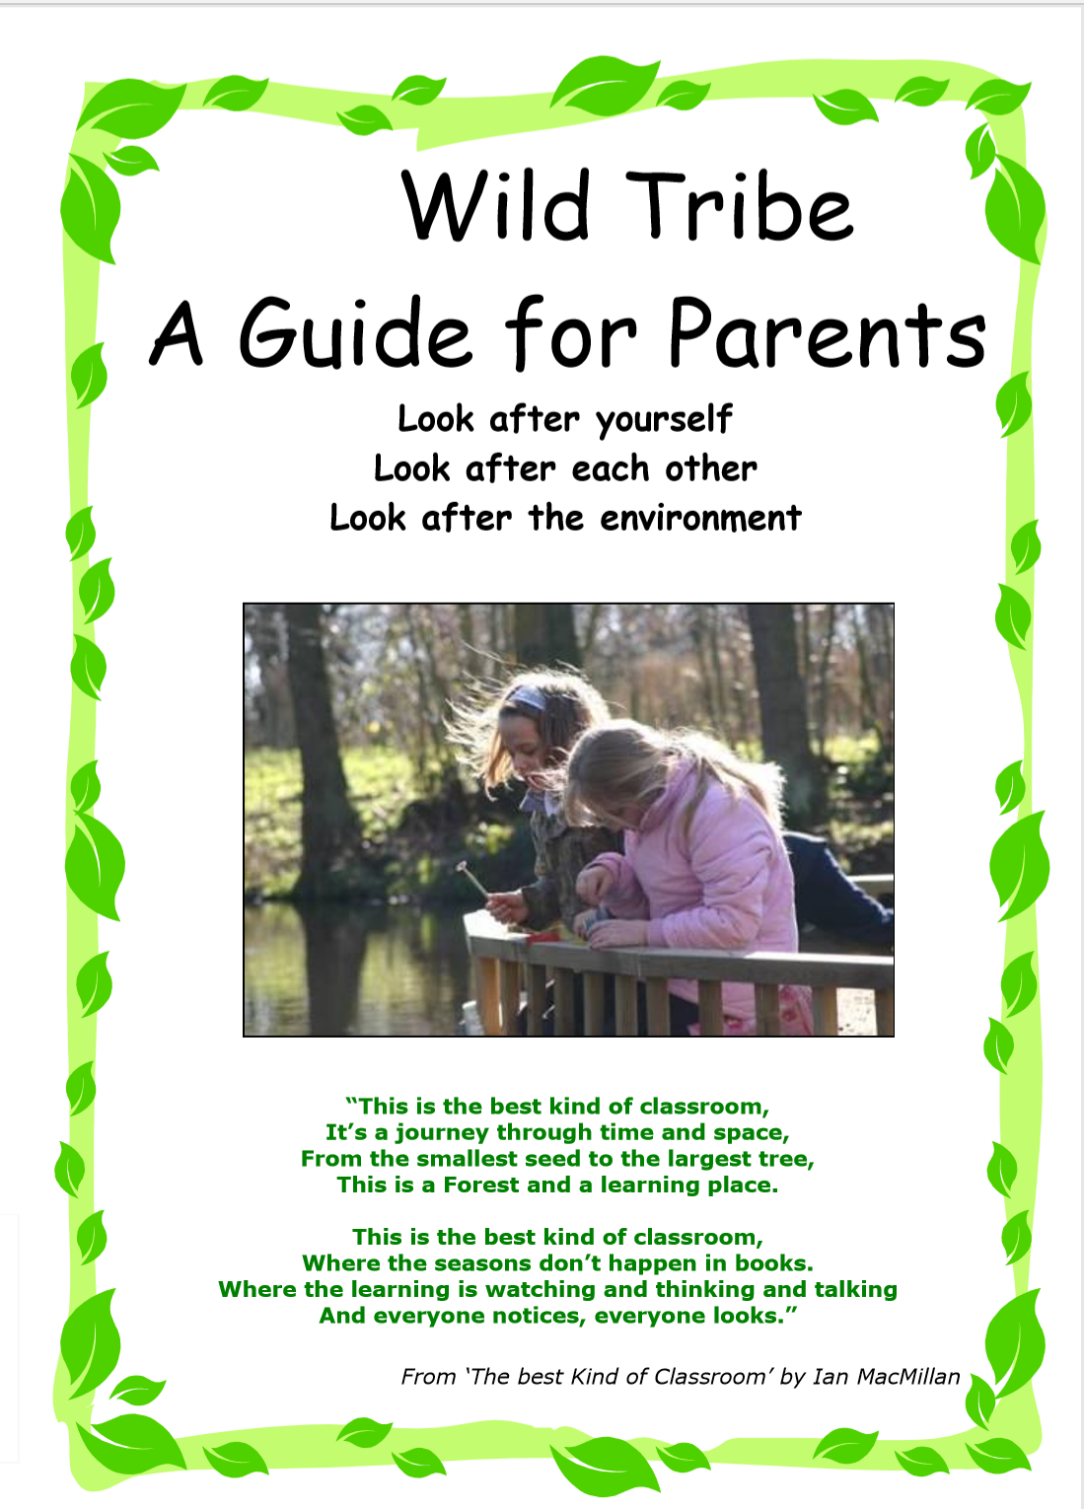
What benefits will my child get from participating in Wild tribe?
Wild Tribe supports the holistic development of the child:
- Health and fitness – being active in an outdoor, natural environment.
- Increased emotional wellbeing – there is a wealth of research supporting this.
- Social development – communicating and negotiating with peers and adults to solve problems and share experiences.
- Skills development – developing fine and gross motor skills and coordination for real purposes.
- Gaining knowledge and understanding – multi-sensory, real life learning.
- Personalised learning – careful observation through small group work allows adults to tailor support to pupils’ own needs, interests and stage of development.

Health and Safety
The health and safety of all the pupils is central to everything done within a Wild Tribe Program. Wild Tribe practitioners are fully trained in Wild Tribe skills and risk assessment. Two supporting adults will also attend every session. All practitioners and supporting adults hold first aid qualifications. The Wild Tribe Program has; a Health and Safety policy, a seasonally and daily risk assessed site, risk assessments for activities and first aid resources. Some of the activities the pupils may participate in are ‘higher-risk activities’ (such as campfire cooking or tool use), however, these activities are not available to children until certain behaviours and boundaries are established. Pupils are encouraged and supported in recognising and managing risk for themselves, through real life situations and experiences.
What does my child need to bring?
Your child just needs to bring themselves! However, what they wear is important. Children must wear long trousers/leggings and long- sleeved tops, have a waterproof jacket and wellies or old trainers and a sun hat. Please be aware, these clothes are likely to get dirty!
You will be informed when your child will be doing Wild Tribe sessions.
What is Wild Tribe? What will the children be doing?
Wild Tribe has been based on the principles of Forest Schools, which The Wild Tribe routine varies depending on the site, however it may
has developed from the Scandinavian education system and is about include:
young people building self-esteem and independence through
exploring and experiencing the natural world. Forest Schools is a *Natural crafts – making necklaces from Elder sticks, creating
long-term program delivered by trained practitioners within a collages from natural objects, weaving using wool and wood
natural environment (not necessarily a forest!). The main difference stick frames etc
between Forest Schools and Wild Tribe is that Wild Tribe has been *Mud/clay sculptures.
developed by teachers and practitioners working alongside each *Shelter building and knot tying
other to ensure that units of exploration meet the needs of all *Using tools for a purpose – such as peeling bark from sticks with
learners not just the Early Years and meets the requirements of potato peelers, whittling the end of a stick to make a marsh mallow
the new National Curriculum, covering a range of curriculum areas. toasting fork, cutting and sawing branches to consistent lengths,
Each Wild Tribe unit of exploration is tailored to meet the needs of drilling holes in wood to attach string etc.
individuals within each group and is continuously developed as the *Fire building and cooking on a campfire.
children grow in confidence, skills and understanding as a result of *Activities linked to literacy, maths, science, art or topic.
their exploration.

The ethos of Forest Schools, allows learners the time and space to Sessions are planned around the individual’s and group’s needs and
develop skills, interests and understanding through practical, hands-on built upon each week. All Wild Tribe Practitioners are qualified through
experiences. It allows practitioners to step back and observe pupils in nationally recognized and accredited training, therefore ensuring that
order to encourage and inspire individuals to achieve through careful Wild Tribe is a high-quality learning experience. The first sessions will
support and facilitation. Wild Tribe has been developed based on concentrate on safety and establishing boundaries and routines. As
these principles of Forest Schools but with our own natural pupils develop in confidence and familiarity with the environment,
Cornish twist! the sessions focus on the development and consolidation of skills and
understanding and link further with the National Curriculum.
Where will pupils be going?
Wild Tribe will be based within short walking distance of the school site. Wild Tribe Practitioner – Mrs Clare Hayes
The sites have some natural features (we may have to import some
natural materials such as sticks, logs, leaves and conkers etc). All
the sites are safe, thoroughly risk-assessed and managed by trained
practitioners.

