National Curriculum Planning Document
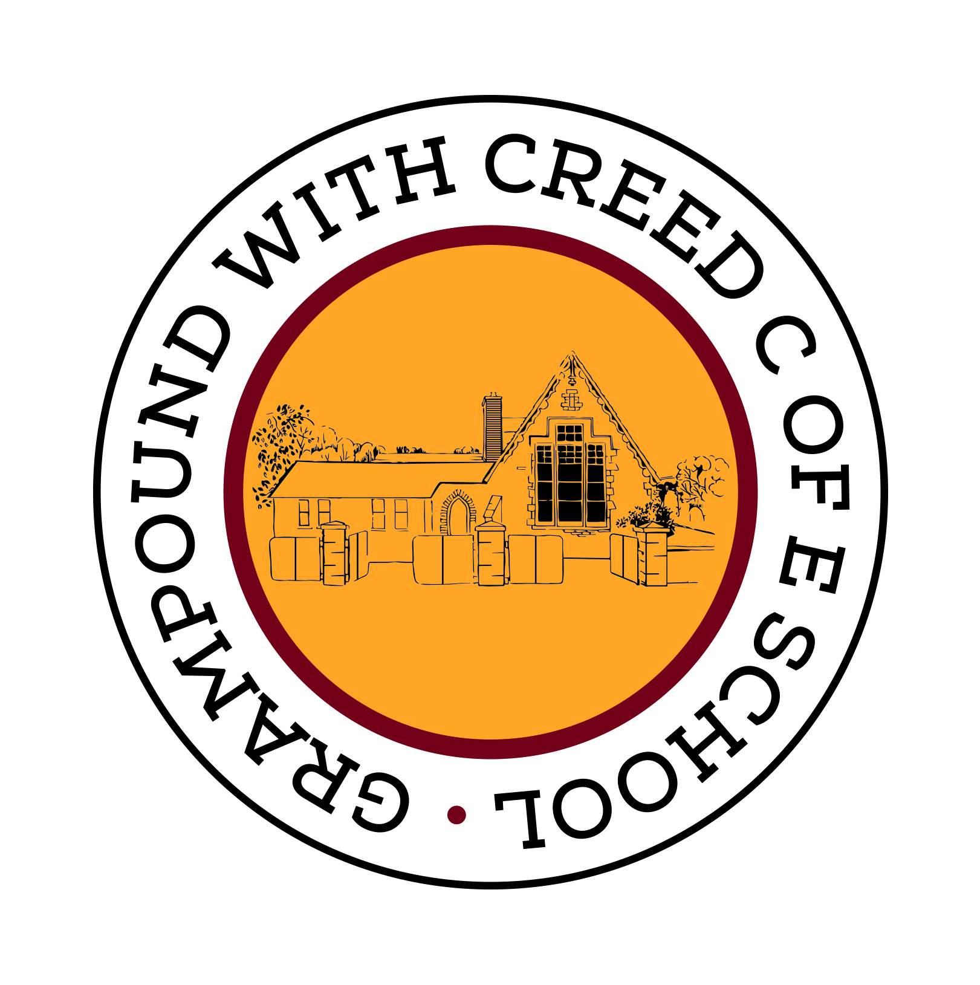
Grampound with Creed School
Y2
Spelling Appendix
This document contains the Y2 Spelling appendix and should be used to support the planning, teaching and learning of Spelling in Year 2.

Spelling – work for year 2

Revision of work from year 1

As words with new GPCs are introduced, many previously-taught GPCs can be revised at the same time as these words will usually contain them.

New work for year 2

Statutory requirements |  | Rules and guidance (non-statutory) | Example words (non-statutory)
The /dʒ/ sound spelt as ge and dge at the end of words, and sometimes spelt as g elsewhere in words before e, i and y |  | The letter j is never used for the /dʒ/ sound at the end of English words.  At the end of a word, the /dʒ/ sound is spelt –dge straight after the /æ/, /ɛ/, /ɪ/, /ɒ/, /ʌ/ and /ʊ/ sounds (sometimes called ‘short’ vowels).  After all other sounds, whether vowels or consonants, the /dʒ/ sound is spelt as –ge at the end of a word.  In other positions in words, the /dʒ/ sound is often (but not always) spelt as g before e, i, and y. The /dʒ/ sound is always spelt as j before a, o and u. | badge, edge, bridge, dodge, fudge  age, huge, change, charge, bulge, village  gem, giant, magic, giraffe, energy  jacket, jar, jog, join, adjust
The /s/ sound spelt c before e, i and y |  |  | race, ice, cell, city, fancy
The /n/ sound spelt kn and (less often) gn at the beginning of words |  | The ‘k’ and ‘g’ at the beginning of these words was sounded hundreds of years ago. | knock, know, knee, gnat, gnaw
The /r/ sound spelt wr at the beginning of words |  | This spelling probably also reflects an old pronunciation. | write, written, wrote, wrong, wrap
The /l/ or /əl/ sound spelt –le at the end of words |  | The –le spelling is the most common spelling for this sound at the end of words. | table, apple, bottle, little, middle

Statutory requirements |  | Rules and guidance (non-statutory) | Example words (non-statutory)
The /l/ or /əl/ sound spelt –el at the end of words |  | The –el spelling is much less common than –le.  The –el spelling is used after m, n, r, s, v, w and more often than not after s. | camel, tunnel, squirrel, travel, towel, tinsel
The /l/ or /əl/ sound spelt –al at the end of words |  | Not many nouns end in –al, but many adjectives do. | metal, pedal, capital, hospital, animal
Words ending –il |  | There are not many of these words. | pencil, fossil, nostril
The /aɪ/ sound spelt –y at the end of words |  | This is by far the most common spelling for this sound at the end of words. | cry, fly, dry, try, reply, July
Adding –es to nouns and verbs ending in  –y |  | The y is changed to i before –es is added. | flies, tries, replies, copies, babies, carries
Adding –ed, –ing, –er and –est to a root word ending in –y with a consonant before it |  | The y is changed to i before –ed, –er and –est are added, but not before –ing as this would result in ii. The only ordinary words with ii are skiing and taxiing. | copied, copier, happier, happiest, cried, replied  …but copying, crying, replying
Adding the endings –ing, –ed, –er, –est and –y to words ending in –e with a consonant before it |  | The –e at the end of the root word is dropped before –ing, –ed, –er,  –est, –y or any other suffix beginning with a vowel letter is added. Exception: being. | hiking, hiked, hiker, nicer, nicest, shiny
Adding –ing, –ed,  –er, –est and –y to words of one syllable ending in a single consonant letter after a single vowel letter |  | The last consonant letter of the root word is doubled to keep the /æ/, /ɛ/, /ɪ/, /ɒ/ and /ʌ/ sound (i.e. to keep the vowel ‘short’).  Exception: The letter ‘x’ is never doubled: mixing, mixed, boxer, sixes. | patting, patted, humming, hummed, dropping, dropped, sadder, saddest, fatter, fattest, runner, runny
The /ɔ:/ sound spelt a before l and ll |  | The /ɔ:/ sound (‘or’) is usually spelt as a before l and ll. | all, ball, call, walk, talk, always
The /ʌ/ sound spelt o |  |  | other, mother, brother, nothing, Monday

Statutory requirements |  | Rules and guidance (non-statutory) | Example words (non-statutory)
The /i:/ sound spelt  –ey |  | The plural of these words is formed by the addition of –s (donkeys, monkeys, etc.). | key, donkey, monkey, chimney, valley
The /ɒ/ sound spelt a after w and qu |  | a is the most common spelling for the /ɒ/ (‘hot’) sound after w and qu. | want, watch, wander, quantity, squash
The /ɜ:/ sound spelt or after w |  | There are not many of these words. | word, work, worm, world, worth
The /ɔ:/ sound spelt ar after w |  | There are not many of these words. | war, warm, towards
The /ʒ/ sound spelt s |  |  | television, treasure, usual
The suffixes –ment,  –ness, –ful , –less and –ly |  | If a suffix starts with a consonant letter, it is added straight on to most root words without any change to the last letter of those words.  Exceptions:  (1) argument  (2) root words ending in –y with a consonant before it but only if the root word has more than one syllable. | enjoyment, sadness, careful, playful, hopeless, plainness (plain + ness), badly  merriment, happiness, plentiful, penniless, happily
Contractions |  | In contractions, the apostrophe shows where a letter or letters would be if the words were written in full (e.g. can’t – cannot).  It’s means it is (e.g. It’s raining) or sometimes it has (e.g. It’s been raining), but it’s is never used for the possessive. | can’t, didn’t, hasn’t, couldn’t, it’s, I’ll
The possessive apostrophe (singular nouns) |  |  | Megan’s, Ravi’s, the girl’s, the child’s, the man’s
Words ending in –tion |  |  | station, fiction, motion, national, section

Statutory requirements |  | Rules and guidance (non-statutory) | Example words (non-statutory)
Homophones and near-homophones |  | It is important to know the difference in meaning between homophones. | there/their/they’re, here/hear, quite/quiet, see/sea, bare/bear, one/won, sun/son, to/too/two, be/bee, blue/blew, night/knight
Common exception words |  | Some words are exceptions in some accents but not in others – e.g. past, last, fast, path and bath are not exceptions in accents where the a in these words is pronounced /æ/, as in cat.  Great, break and steak are the only common words where the /eɪ/ sound is spelt ea. | door, floor, poor, because, find, kind, mind, behind, child, children*, wild, climb, most, only, both, old, cold, gold, hold, told, every, everybody, even, great, break, steak, pretty, beautiful, after, fast, last, past, father, class, grass, pass, plant, path, bath, hour, move, prove, improve, sure, sugar, eye, could, should, would, who, whole, any, many, clothes, busy, people, water, again, half, money, Mr, Mrs, parents, Christmas – and/or others according to programme used.  Note: ‘children’ is not an exception to what has been taught so far but is included because of its relationship with ‘child’.

