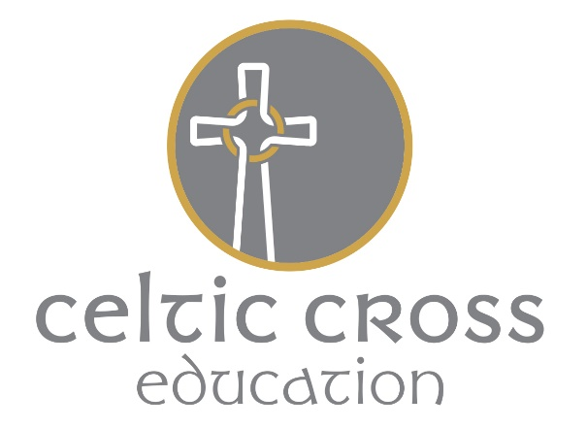

Collective Worship Policy

Introduction

Grampound with Creed School is a Voluntary Aided school serving a village community in an almost totally and mostly nominal Christian area. However, the pupils are not immune from developments and influences in a wider world, through family and personal contacts, the media, and from their education. It is part of the aims of the school to offer a wide-ranging education, to prepare pupils for life not only in their own community but also in a wider world.

Legal Requirements

- All pupils must take part in a daily act of collective worship, unless they have been withdrawn from it by their parents.

- Parents have the right to withdraw their children from collective worship.

- As Grampound with Creed is a Voluntary Aided School, collective worship will be ‘of a wholly Christian character’, that is to be within, or linking to, the traditions of Christian beliefs on all occasions.

- Collective worship must acquaint children with Anglican approaches where appropriate and possible.

Aims for Collective Worship

The following aims have been agreed with the Governors:

- To establish, affirm, and celebrate the common and shared values of the school

- To nurture the identity and nature of the school as a community

- To develop positive attitudes among the pupils

- To provide an opportunity for pupils to worship God

- To enable pupils to come to terms with their own beliefs, values and commitments, and with those of others

- To promote the spiritual, moral, social and cultural development of pupils

- To acquaint children with the presence of the Church in the community

- To celebrate achievement on the part of individuals or groups of children

- To experience moments of silence and reflection

- Worship is understood as an act of collective worship in school and can be interpreted very openly and widely as an act which brings the whole school to a point where they are able to make a shared, reflective response to a divine being, power, ideal or value of some worth, wholly or mainly within the broad traditions of Christian belief on the majority of occasions.

- Collective worship is an essential element in the schools' promotion of the spiritual and moral development of pupils as required by ERA 1988.

Approaches

- The aim is to enable children to approach the threshold of worship

- Daily worship is provided through whole school acts of worship

- When appropriate, special occasions will be marked by a form of service in church

Management

Responsibility for collective worship in Grampound with Creed School lies with the RE Co-ordinator and Head of School whose task is:

- to provide a sequence of themes for each week – including pupil led worship where appropriate

- to establish and maintain a resource base

- to liaise with the local community in terms of visitors

- to arrange visits from the local vicar as regularly as is possible

- to arrange use of Parish Church on special occasions

- to arrange visits from other religious representatives

Staffing

Staff will be asked to share the role of worship leader. On days when they are not leading, they will not normally be expected to attend. On one day a week, the children will be rewarded for achievement and termly special assemblies will be attended by all staff. Some teaching staff will normally attend if there is a visiting speaker.

Methods

There should be a suitable variety of methods for collective worship to enable the experience to be as valid and relevant to the pupils as possible. There will also be a ritual element associated with some of these methods to allow the pupils to benefit from the security and pattern of worshipping together.

These will include the following as is appropriate to the nature of the occasion.

- Music on entry and exit, various themes and cultures
- Hymn singing daily
- Use of prayers, including the children's own, and the Lord's Prayer
- Readings from suitable sources, including the Bible, but also other sources of worth
- Stories to illustrate themes
- Periods of silence for reflection
- Lighting of a candle

Resources

The school maintains a resource base for collective worship with the RE Resources.

Recording

All acts of worship are timetabled according to content and hymns sung are recorded on the sheet in the office.

Timing

Collective Worship will take place daily at varying times.

Evaluation

- Governor monitoring of Collective Worship by Foundation Governor termly
- 3 year evaluation and update of Collective Worship Themes – Summer 19
- Review of record keeping for Collective Workshop Annual

This policy was written in January 1998 and was agreed by the Governing Body on 22nd September 1998. It will be reviewed bi-annually. Its implementation and effectiveness will be monitored by the Head of School and the Governor responsible for Collective Worship and their evaluation used in the review of the policy.
The School is aware of and sympathetic to the potential individual needs of all of our stakeholders. These unique needs may be due to a wide range of circumstances of a long or short duration. We will endeavour to accommodate these to ensure an inclusive approach by promoting positive images and experiences of differing race, gender, LGBT and abilities.

This policy was last approved by the local (SMC) on March 7th 2018.

