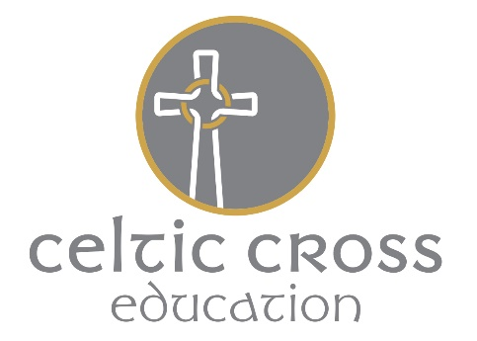_________________________________________________________________________________________________________

Grampound with Creed C of E School
Fore Street, Grampound, TR2 4SB
grampoundwithcreed.secretary@celticcross.education
01726 882644 www.grampoundwithcreedschool.co.uk

27th November 2019
Dear parents,
Reception and Nursery Trip to The Rogue Theatre

On Friday 13th December, Reception and Nursery children will be going on a trip to The Rogue Theatre in Tehidy Woods for a Christmassy adventure and live production. We plan to travel to the woods by minibus leaving at 12pm and returning around 4pm. Children will need to wear school uniform and bring a coat and sensible shoes for walking (trainers, walking boots or wellies) in a carrier bag.

Please provide your child with a drink bottle and a BIG packed lunch so that they can eat half before we leave and then the rest on the minibus on the way home (things that are easy to eat while travelling please!!). If you would like to order a school packed lunch, please order by Friday 6th December.

The cost of this trip is £8.00, to cover the cost of travel and your child’s entry into the theatre. Although this is a voluntary donation, we will not necessarily be able to run the trip without it and we thank you for your support with this.

For more information on this trip, please visit roguetheatre.co.uk.

Kind Regards,
The EYFS team
------------------------------------------------------------------------
GRAMPOUND WITH CREED CHURCH OF ENGLAND SCHOOL –
Parental Consent Form
This form has been produced for parents/guardians of children at Grampound with Creed Church of England School to complete with regard to visits and journeys. Please note that in signing this form your rights are not affected in any way.
Visit/Activity Rogue Theatre
Date Friday 13th December 2019

I wish my child _____________________________to be allowed to take part in the above mentioned visit/activity and, having read the information provided, agree to him/her taking part in any of the activities described.

I consent to any emergency medical treatment required by my child during the course of the visit.
I confirm that my child does not suffer from any medical condition requiring regular treatment OR my child suffers from________________________________________ requiring regular treatment (e.g. diabetes, asthma). If your child suffers from a particular complaint, please give details of the complaint and its treatment on the back or this form.
I consent to my child travelling by any form of public or contracted transport.
I consent to my child travelling in a car to be driven by a parent or teacher who is suitably insured.
Signature of Parent/Guardian _________________________________ Date __________________
Telephone Numbers: Home_____________ Work ___________________ Other ___________________

