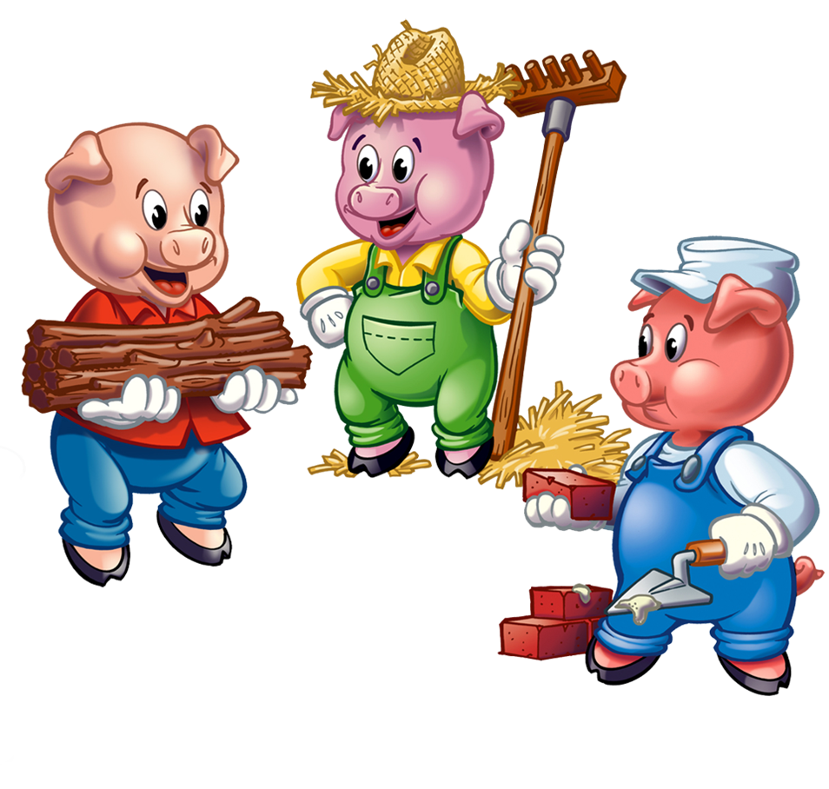
Personal, Social and Emotional Development
Children will be…
- Deciding the’ Golden Rules’ for our classroom.
- Building relationships and learning to play cooperatively.
- Finding out about each other’s likes and dislikes.
- Listening to and following simple instructions.

Communication and Language
Children will be…
- Sharing their ‘All About Me’ boxes from home.
- Listening carefully to a variety of stories.
- Learning the stories ‘The 3 Little Pigs’ and ‘Owl Babies’ and discussing the plot and characters.
- Taking it in turns to talk during conversation.

RE
Children will be…
- Discussing our school rules and values.
- Exploring and wondering about the natural world.
- Finding out about the importance of Harvest.

Mathematics
Children will be…
- Counting to 10 (pointing at each object as they say the number)
- Matching numeral to quantity.
- Recognising numbers 0-10, out of order.
- Saying the number that is one more and one less than (within 10).
- Exploring and investigating numbers 1 to 5 using Numberblocks.

Phyiscal Development
Children will be…
- Climbing and exploring in the park.
- Learning new skills in PE with Mr Webb.
- Enjoying themed yoga and mindfulness sessions with Cosmic Kids.
- Using different classroom equipment, such as; scissors, staplers, cutters and rolling pins to perform different tasks.
- Chopping vegetables in the outdoor kitchen.
- Exploring malleable materials, such as; sand, rice and playdough.
- Learning to hold a pencil correctly.
- Changing independently for PE.

“I am Special!”
Pedrevan Class
Autumn 1 2020

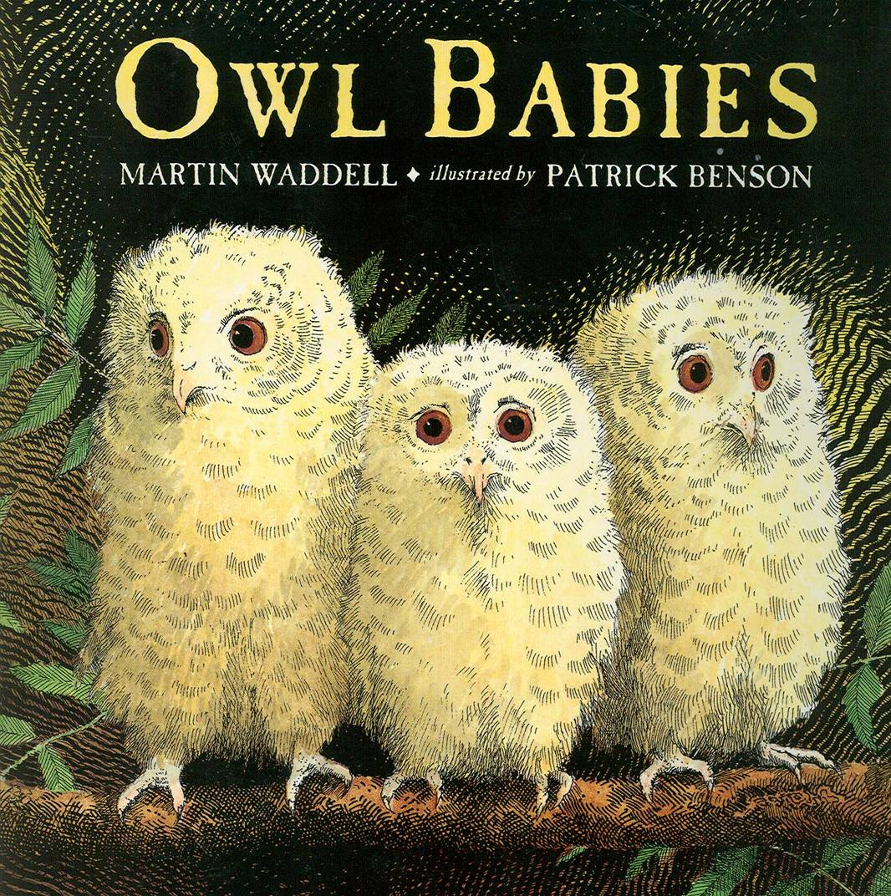
Understanding the World
Children will be…
- Observing seasonal similarities, differences and changes.
- Exploring nature in the school field and gardens.
- Constructing houses uses straw, sticks and bricks, and finding out about different houses around the world.

Literacy
Children will be…
- Learning the Read Write Inc Set 1 sounds and begin using them to read and write simple words.
- Writing their name.
- Writing the names of the people and pets in their family.
- Using their phonic knowledge to write the names of the characters in ‘The Three Little Pigs’ and speech bubbles for characters from ‘The Three Little Pigs’ and ‘Owl Babies’.

Expressive Arts and Design
Children will be…
- Painting an observational picture of themselves for our class display.
- Using collage techniques to create Autumn and Harvest pictures.
- Making houses using straw, sticks and bricks, just like the Three Little Pigs!


