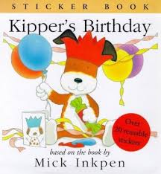
Personal, Social and Emotional Development
Children will be…
- Continuing to embed our Golden Rules throughout their school day.
- Learning to respect and understand other cultures and beliefs.
- Developing their confidence to talk to other children when playing and communicating freely about own home and community.

Communication and Language
Children will be…
- Learning the stories ‘Kipper’s Birthday’ and ‘Jolly Christmas Postman’.
- Retelling and sequencing the stories using stick puppets and story maps.
- Acting out the stories through role play.
- Responding to the stories through creative arts.

Understanding the World/RE
Children will be…
- Learning why we celebrate bonfire night.
- Learning the Diwali story and how Diwali is celebrated.
- Tasting and describing Indian food.
- Discussing what they celebrate at home, including birthdays and Christmas.
- Learning about the Cornish Festival of Light.
- Learning the Nativity story.

Phyiscal Development
Children will be…
- Visiting the park.
- Playing on the bikes and scooters.
- Learning new multi-skills with Miss Danks and Mr Webb in PE!
- Using the Huff and Puff equipment.
- Enjoying weekly themed yoga sessions with Cosmic Kids videos.
- Using different classroom equipment to perform different tasks (cutting with scissors etc).
- Learning to hold a pencil correctly.
- Changing independently for PE.
- Indian dancing.

Let’s Celebrate!

Pedrevan Class - Autumn 2 2018
Mathematics
Children will be…
- Counting, reading, writing and ordering numbers to 20.
- Naming 2d and 3d shapes.
- Creating shape patterns for wrapping paper.
- Reading O’Clock times.
- Sequencing ordinal numbers using the 12 days of Christmas song.
- Weighing ingredients.

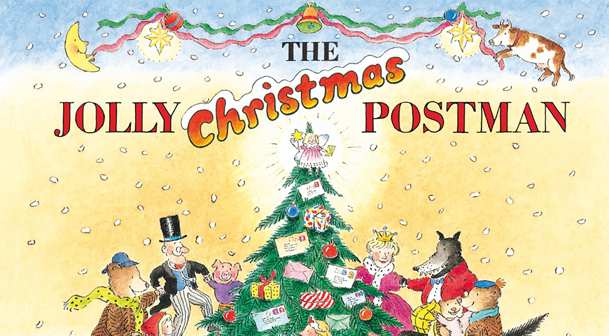

Expressive Arts and Design
Children will be…
- Creating firework pictures.
- Making Diva lamps.
- Learning Indian dance.
- Creating their own Rangoli patterns.
- Making birthday and Christmas decorations.
- Baking and decorating party food!
Literacy
Children will be writing…
- Sentences, using phonics and red words.
- Adjectives to describe fireworks.
- Labels for story characters.
- Shopping lists.
- Christmas cards.
- Letters to Santa.

