 |  |  |  |  |  | Once Upon a Time
 | Key Vocabulary |  |  |  |  | Key Learning  - The way that people lived in the past is not the same as the way that we live now. There have been changes to schools, play activities, toys, food, transport and clothes  - Kings and queens are known as royalty.  - Some kings and queens are real people and some are characters in stories.  - Queen Elizabeth II has reigned for 70 years and we are celebrating her Platinum Jubilee this year.  - Rules keep us safe when using equipment.  - Safety rules include always listening carefully and following simple instructions, using equipment only for the tasks they are designed for and washing hands before touching food.  - A healthy breakfast is an important start to the day.  - There are different types of bridges for different purposes.  - People around the world live in different types of homes.  - Different materials have different properties and can be used for different purposes.
 | Tier 1  Build  House  Straw  Sticks  Bricks  Bridge  River  Meadow  Woods  Porridge  Castle  A long time ago  In the past  Once upon a time | Tier 2  Characters  Setting  Traditional  Tale  King  Queen  Royal  Royalty  London  Palace  Celebrate  Healthy  Materials  Constuct/ion  Design/ed | Tier 3  Platinum  Jubilee  Queen Elizabeth II  Buckingham Palace  Reign  Yurt  Tippee  Igloo  Beam bridge  Arch bridge  Cantilever bridge  Suspension bridge
 | Key Texts  *Cinderella *Goldilocks  *3 Little Pigs *Little Red Riding Hood  *3 Billy Goats Gruff |  |  |  |  | Key songs/rhymes  - When Goldilocks went to the house of the bears  - The 3 bear’s rap (Music Express) | Online resources  - YouTube – Silly Symphony-The 3 Little Pigs  - Twinkl PPT – Homes around the world  - Twinkl PPT – How do we build bridges
 |  |  |  |  |  | Key Themes
 | Traditional Tales  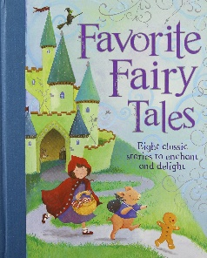 |  |  |  |  | Kings and Queens  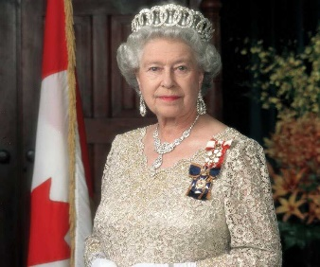 |  | Materials and Construction  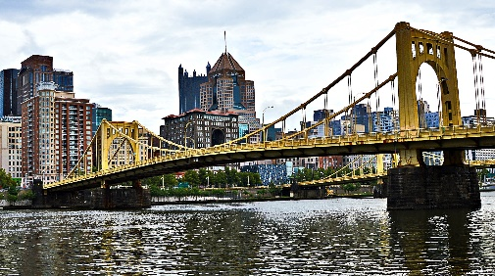
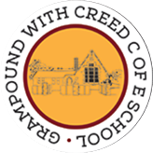
Grampound with Creed School - EYFS – Knowledge Organiser

