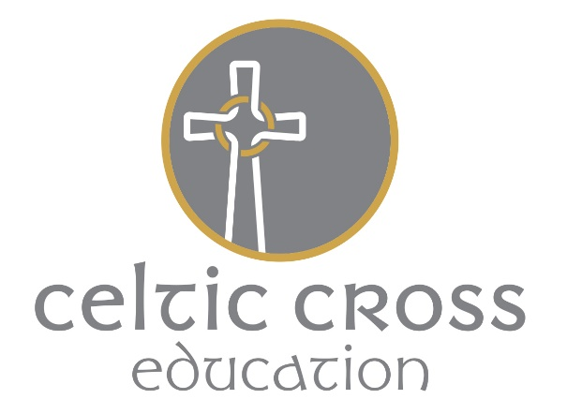

R.E. POLICY

Context

Grampound with Creed School is a small Voluntary Aided Primary School, serving a settled community in an almost totally and mostly nominal Christian area of the south west of England. However, the pupils are not immune from developments in and influences from a wider world, through family and personal contacts, the media and from their education. It is a part of the aims of the school to offer a wide-ranging education, to prepare pupils for life not only in their own community but in a wider world.

Legal Requirements

RE is a core subject, part of the basic curriculum of the school, and must be taught to all pupils, unless they have been withdrawn from it by their parents.

Parents have the right to withdraw their children from RE, following discussion with the Head of School and a letter to the Governing Body.

Grampound with Creed School is a Church of England primary school and part of the St Piran’s Cross CofE Multi-Academy Trust. The Governors, following recommendation from the Diocesan Board of Education, have made the decision that RE is taught with regard to the Agreed Syllabus of the Cornwall LEA and the Diocesan Board’s guidelines. This recommends that up to 10% of curriculum time is spent on RE, in addition to the daily Act of Worship. Time spent on RE is therefore around 1.5 hours per week. This will be covered by weekly lessons, RE focus days and Prayer weeks. Christianity is taught for at least 60% of the time.

Aims for R.E.

These are set out in the New Cornwall Agreed Syllabus, and are summarised:-

To acquire and develop knowledge and understanding of Christianity and the other principal religions of Great Britain.

To give some experience of what it is to be a member of a faith community without indoctrination.

- To consider questions of meaning and purpose in life.

To develop the ability to make informed judgements about religious and moral issues with reference to the principal religions of Great Britain, their belief systems and ethical teaching.

To explore issues within and between faiths to help the children understand and respect different religions, beliefs, values and traditions, and to understand the influence of these on individuals, societies, communities and cultures.

To enhance their spiritual, moral, cultural and social awareness by responding to fundamental questions with reference to the teaching and practices of religions.

To develop a positive attitude to other people, respecting their right to hold different beliefs from their own, and to develop their sense of identity and belonging, preparing them for life as citizens in a plural society.

The school fully accepts these aims as appropriate for RE for the pupils at Grampound with Creed School and they have been used to inform the planning, teaching and learning.

Skills, Attitudes, Knowledge and Understanding in RE

These again are set out in the New Cornwall Agreed Syllabus. The school fully accepts responsibility for developing these in its RE and across the subjects of the curriculum.

Spiritual and Moral Development of Pupils

Through these aims, skills, attitudes, concepts and knowledge, RE contributes fully and positively to the spiritual, moral, cultural and social development of the pupils. This is promoted throughout the school - its ethos, curriculum and its worship. This area is fully explored in our SMSC Policy.

Approaches to RE

RE will be provided through:-

(a) the normal integrated topic work of the school where ever it is possible to do so with integrity to the subject and topic.

(b) discrete RE topics, RE FOCUS DAYS and PRAYER WEEKS where this is felt to be a more effective
method of teaching and learning, and use of the new ‘Understanding Christianity’ materials used.

Management of RE

The School Co-ordinator, Miss Catherine Coffee, with support of the whole school staff will:-

review and update school policy on RE
review and update Scheme of Work for RE
ensure continuity and progression in RE through the school
advise on methods of teaching and learning
develop a system for assessing and recording progress in RE
develop and maintain a resource base for RE
co-ordinate In service training in RE
develop and maintain a development plan for RE
monitor and evaluate the effectiveness of RE
- prepare for Section 48 Inspection, to liaise with the Inspector and to prepare relevant material for him/her.
- ensure the smooth running of the inspection process.

Foundation

Pupils are encouraged in their personal, social, moral and spiritual development. They develop an understanding of personal values, of self and others. They are encouraged to co-operate with others in a group beyond the family and begin to learn about groups of people and their beliefs. They are taught about Christianity, visit the parish churches and enjoy stories about Jesus.

Methods in RE

RE will use the full range of teaching and learning methods as appropriate for the age, development and abilities of the pupils, and for the purpose and content of the work, including:

the use of artefacts
whole-class teaching
individual research and resource-based learning
visits to buildings and places outside school
visits from outside speakers
use of the basic skills of reading, literacy, numeracy, and artwork
use of the internet
use of audio-visual resources such as CDs.
differentiated work for pupils of different ability

Resources

- Set of Bibles (Rainbow Good News)
- Good range of books on various faiths and festivals.
- Boxes of artefacts from World Faiths, including Christianity, Judaism, Hinduism & Islam.
- RE online – Internet
8. RE Quest
Assessment and Recording
The school believes that it is very important to monitor the progress of its pupils in RE as in any other subject.

AT1 Learning about Religions AT2 Learning from Religion

Assessment will be based on the learning objectives specified for that topic/area of work as indicated in the schemes of work. Pupils progress in RE will be assessed using the Culham ‘I can’ statements from RE online as a basis. They are tracked using this.

An Annual RE Work Scrutiny will take place at the end of each Summer term.

Reporting RE

It is a legal requirement that the school issues a written report of progress in RE for each pupil annually. This will be done in July along with reports for other subjects of the National Curriculum. The report will contain comment on the effort, general progress of the pupils.

Other reporting takes place on Parents’ Evenings, when progress in RE is discussed along with other National Curriculum subjects and parents have an opportunity to look at children’s work.

Governor responsibility.

The RE (SMC member) is Mrs Ann Jones.
Evaluation of Policy
The original policy was written in November 2000 and approved by the Governors. It was reviewed by the Headteacher in September 2002. The previous Scheme of Work was discarded and the new Agreed Syllabus put in place in Autumn Term 2000, along with new Long Term planning. Following the RE inspection (Section 23) of December 2002, the policy has been further reviewed (May 2003) in line with the inspector’s recommendations.

The School is aware of and sympathetic to the potential individual needs of all of our stakeholders. These unique needs may be due to a wide range of circumstances of a long or short duration. We will endeavour to accommodate these to ensure an inclusive approach by promoting positive images and experiences of differing race, gender, LGBT and abilities.

This policy was approved by the Local SMC on March 7th 2018.
Most recently reviewed and names /roles updated September 2019. (Full update awaiting new RE syllabus.)

