National Curriculum 2014 Planning Document
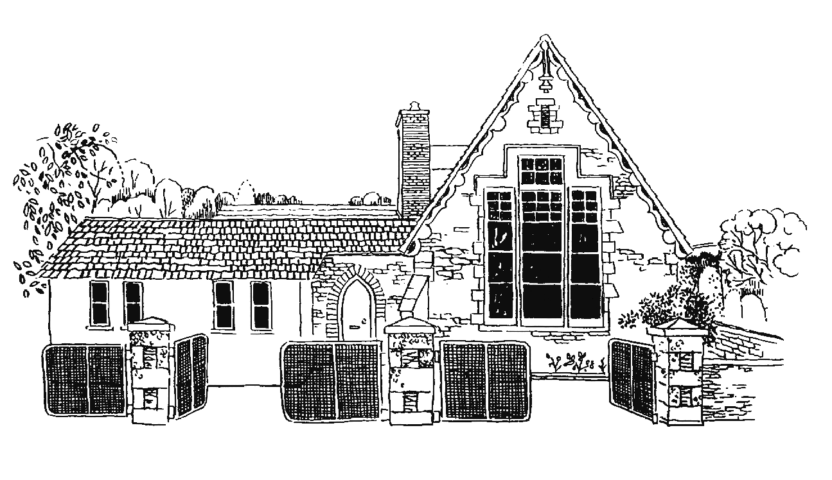
Grampound with Creed School
Y6
Vocabulary, Grammar and Punctuation Appendix
This document contains the Y6 Vocabulary, Grammar and Punctuation appendix and should be used to support the planning, teaching and learning of Spelling in Year 6.

Year 6: Detail of content to be introduced (statutory requirement)
Word | The difference between vocabulary typical of informal speech and vocabulary appropriate for formal speech and writing [for example, find out – discover; ask for – request; go in – enter]  How words are related by meaning as synonyms and antonyms [for example, big, large, little].
Sentence | Use of the passive to affect the presentation of information in a sentence [for example, I broke the window in the greenhouse versus The window in the greenhouse was broken (by me)].  The difference between structures typical of informal speech and structures appropriate for formal speech and writing [for example, the use of question tags: He’s your friend, isn’t he?, or the use of subjunctive forms such as If I were or Were they to come in some very formal writing and speech]
Text | Linking ideas across paragraphs using a wider range of cohesive devices: repetition of a word or phrase, grammatical connections [for example, the use of adverbials such as on the other hand, in contrast, or as a consequence], and ellipsis  Layout devices [for example, headings, sub-headings, columns, bullets, or tables, to structure text]
Punctuation | Use of the semi-colon, colon and dash to mark the boundary between independent clauses [for example, It’s raining; I’m fed up]  Use of the colon to introduce a list and use of semi-colons within lists  Punctuation of bullet points to list information  How hyphens can be used to avoid ambiguity [for example, man eating shark versus man-eating shark, or recover versus re-cover]
Terminology for pupils | subject, object  active, passive  synonym, antonym  ellipsis, hyphen, colon, semi-colon, bullet points

