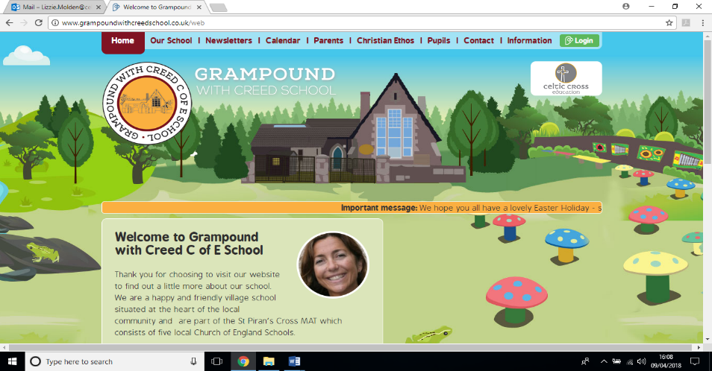

**What Did The Victorians Do For Us?**

**Kwilkyn Class**

**Essential Knowledge**

By the end of this unit the children will know…

* Who was Queen Victoria and when did she reign?
* What was the British Empire and how far did it spread?
* Which inventions do we still use today?
* When was the Industrial Revolution and what was the impact?
* Where did the Victorians go on holiday?
* How did transport change through the period?

**Launch**

**Victoriana!**

To begin our topic, we will learn about Queen Victoria and her family and explore the timeline of her reign.

Then we will look further afield and explore other countries in the British Empire and just how Britain ruled so much of the World’s population.

**Explore**

**Victorian Inventions**

The Victorian Era created developed many products and appliances that changed the lives of the people living during this age. We will be investigating our favourites and looking at some of the major inventors of the age.

**Energise**

**The Industrial Revolution**

After half term, we will be focussing on the Industrial Revolution. We will learn about improvements in transport and major industrial inventions such as the steam engine, and the effect these had on British industries.

**Celebrate**

**Punch and Judy!**

**To finish our topic we will learn about Victorian holidays. Children will create Punch and Judy puppets and write a script for their own show.**

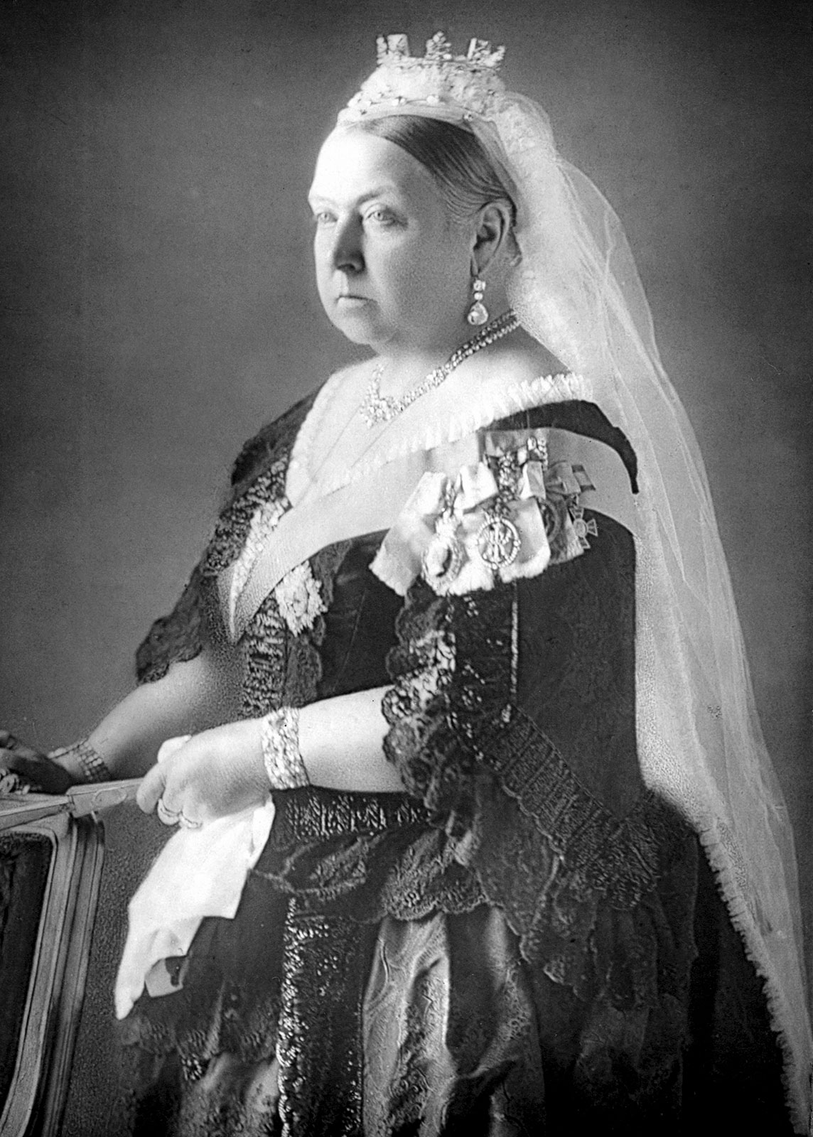



**History & Geography**

* Locate countries of the British Empire.
* Create a timeline of the Victorian Era.
* Investigate major discoveries and inventions of the era.
* Study the industrial revolution, its key figures and major developments.
* Learn about improvements in transport and the effect these had on industry and holidays.

**What did the Victorians do for us? – Theme Content**

**Art and Design & Design and Technology**

* Explore the work of William Morris and recreate some of his designs.
* Use decoupage to create Victorian style artwork.
* Learn about Isambard Kingdom Brunel and design bridges based on his ideas.
* Create our own Punch and Judy puppets
* Sketch and paint

**Core Subjects**

**Personal Development**

**Foundation Subjects**

**English**

* Study ‘Alice in Wonderland’ by Lewis Carroll.
* Innovate a chapter in a fantasy setting.
* Write a biography of a famous Victorian who has left their mark on the world.
* Investigate Jabberwocky by Lewis Carroll and create our own nonsense poetry

**Cultural**

* Who was St Piran and why do we celebrate his day?
* Which other saints are important to Cornish people?

**Social**

* Work together, sharing ideas, showing respect for others’ suggestions and ideas.
* Use growth mindset to overcome problems and be confident to have a go.

**Moral**

* Why is it important to be kind and help others?
* What do the values of ‘respect’ and ‘compassion’ look like?

**Computing**

* Create a multimedia presentation about daily life in Victorian Britain.
* Use computers to research and write a biography of a famous Victorian.

**Spiritual**

* Learn about Hindu beliefs and their Gods and Goddesses
* How do Quakers practise their religion?

**Music & Physical Education**

* Learn about Music Hall songs of the Victorian Era
* Investigate ‘The Carnival of the Animals by Saint-Saens
* Work in groups to create a dance routine
* Develop ball skills to be able to play invasion games.

**Mathematics**

**Number – Mulitplication and Division**

* Children to become confident in their ability to multiply and divide larger numbers and apply mastery to word problems.

**Number – Addition and Subtraction**

* Children to become confident in order to apply mastery to more difficult problems.
* **Number – Fractions, Decimals and Percentages**
* Children to be able to understand fractions and convert between decimals and percentages.

**Science**

* Children will learn about electricity in science. They will study how to make a circuit and how to sort materials into conductors and insulators.
* We will find out about the lives of major inventors in the field – Tesla and Edison

