 |  |  |  |  |  | Exploring Autumn
 | Key Vocabulary |  |  |  |  | Key Learning  - There are four seasons in the year.  - In Autumn, the weather gets colder, on many trees the leaves change colour and drop off.  - Seeds grow on trees and flowering plants.  - Pumpkins, apples and other fruit are ready to harvest and contain seeds.  - Seeds grow into new plants.  - Wheat is ready to harvest. This was done by hand in the past but is now done by combine harvester.  - Wheat is threshed to remove the corn, which is crushed to make flour. They was done in the past by hand and then millstones. Today, it is done in a factory.  - Flour is used as an ingredient in bread, cakes and cereals.  - Christians celebrate Harvest festival and say thanks to God.  - Squirrels and other animals gather and store food for the winter.  - Hedgehogs and other animals begin to hibernate.
 | Tier 1  In the past  Now/today  Leaf/leaves  Seeds  Apple  Pumpkin  Blackberries  Wheat  Flour Pine cone  Hedgehog Acorn  Squirrel Conker | Tier 2  Weather  Season  Autumn  Crushed | Tier 3  God  Christians  Harvest Festival  Combine Harvester  Threshing  Millstones  Ingredients  Hibernate
 | Key Texts  - The Gruffalo  - Stick man  - The Tiny Seed  - The Little Red Hen |  |  |  |  | Key songs/rhymes  - Harvest song | Online resources  - Twinkl PowerPoint ‘Autumn - what do you see’
 |  |  |  |  |  | Key Themes
 | Signs of Autumn |  |  |  |  | Celebrating Harvest
 | 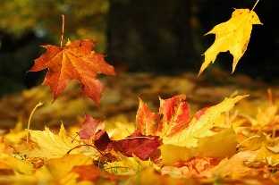 |  |  |  |  | 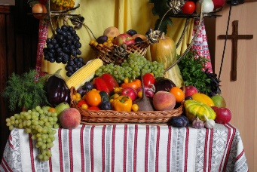
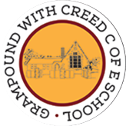
Grampound with Creed School - EYFS – Knowledge Organiser

