National Curriculum 2014 Planning Document
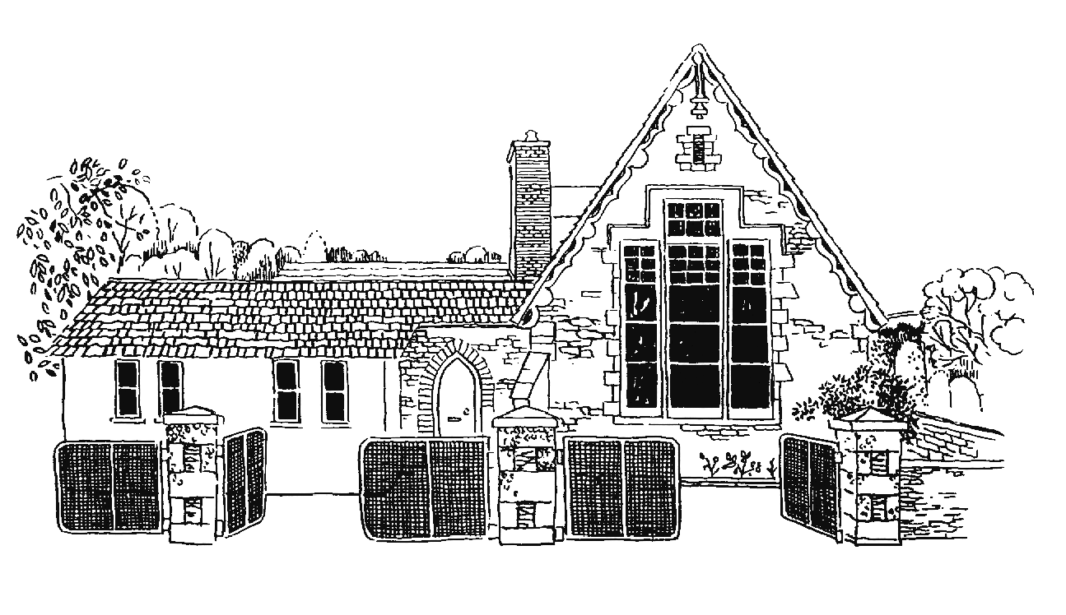
Grampound with Creed School
Y5
Vocabulary, Grammar and Punctuation Appendix
This document contains the Y5 Vocabulary, Grammar and Punctuation appendix and should be used to support the planning, teaching and learning of Spelling in Year 5.

Year 5: Detail of content to be introduced (statutory requirement)
Word | Converting nouns or adjectives into verbs using suffixes [for example, –ate; –ise; –ify]  Verb prefixes [for example, dis–, de–, mis–, over– and re–]
Sentence | Relative clauses beginning with who, which, where, when, whose, that, or an omitted relative pronoun  Indicating degrees of possibility using adverbs [for example, perhaps, surely] or modal verbs [for example, might, should, will, must]
Text | Devices to build cohesion within a paragraph [for example, then, after that, this, firstly]  Linking ideas across paragraphs using adverbials of time [for example, later], place [for example, nearby] and number [for example, secondly] or tense choices [for example, he had seen her before]
Punctuation | Brackets, dashes or commas to indicate parenthesis  Use of commas to clarify meaning or avoid ambiguity
Terminology for pupils | modal verb, relative pronoun  relative clause  parenthesis, bracket, dash  cohesion, ambiguity

