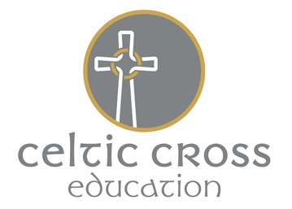
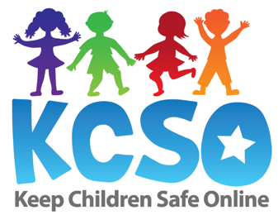
Keeping Children Safe Online

Following school closures, and families confined to their homes, we are aware that use of the internet, apps, gaming devices and online services are being accessed more than ever. Use of the internet provides a lifeline to many of us and has a number of benefits, from home learning, to staying in touch with loved ones. As time becomes an advantage to us all, it is vital that we continue to raise awareness of staying safe online, especially for Celtic Cross pupils. This seems a sensible time to reiterate to everyone a few key points to keep your child/ren safe online:

1/ Talking with children about technology use…

Open and honest conversations with children about what they are doing online is vital at any time, but especially at this point in time when your child might be making more extensive use of technology. Check in on their technology use regularly – find out about what they are doing online, what new tools and apps they might be using; select tools and content together and discuss why certain tools and apps might not be appropriate. Equally, keep the lines of conversation open; your child may have concerns regarding things they have encountered online; let them know that they can discuss any issues and that you'll find a solution together.

2/ Online learning

Remember, parents shouldn't be trying to recreate a school environment at home. As well as the home learning set by teachers, there is a wealth of information for pupils to access online. Ensuring that sites are reputable and safe for your child is a priority; the South West Grid for Learning offer a range of safe activities for children to access in their resources section. For those who are engaging with any online tutoring, the SWGfL provide pointers to reputable companies and resources.
This is also an excellent website to support families with online safety. (swgfl.org.uk)
3/ Online contacts and connections

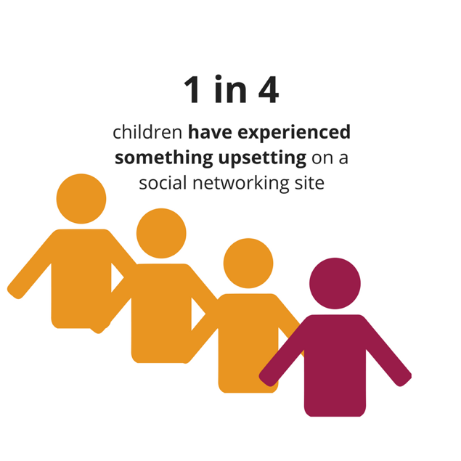
The recommended age for a social media account is set at 13 and over. Social media, access to apps and gaming devices opens up the possibility of communication with strangers; children should remember that they can never be fully aware of who they are talking to online, and that they are free to shut down any conversations which make them feel uncomfortable in any way. Continue to monitor your child’s activity and encourage open discussion regarding online activity.

4/ Other considerations…
- Choose carefully- support your child in accessing age appropriate content and set appropriate privacy settings- the ‘BIK guide to online services’ can help you with this
- Ensure children keep personal info private
- Encourage… ‘Think before you share.’
- Beware of scams; if it sounds too good to be true, it probably is!
Other Forms of Support Available to Parents:
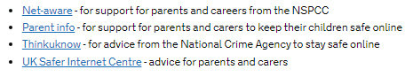

5/ What should I do if I have concerns about a child, or a child’s online activity?

If this relates to an incident within school, you should contact the Head of School who is the setting’s Designated Safeguarding Lead. For concerns outside of school, you should call the local Multi Agency Referral Unit on 0300 1231 116.

