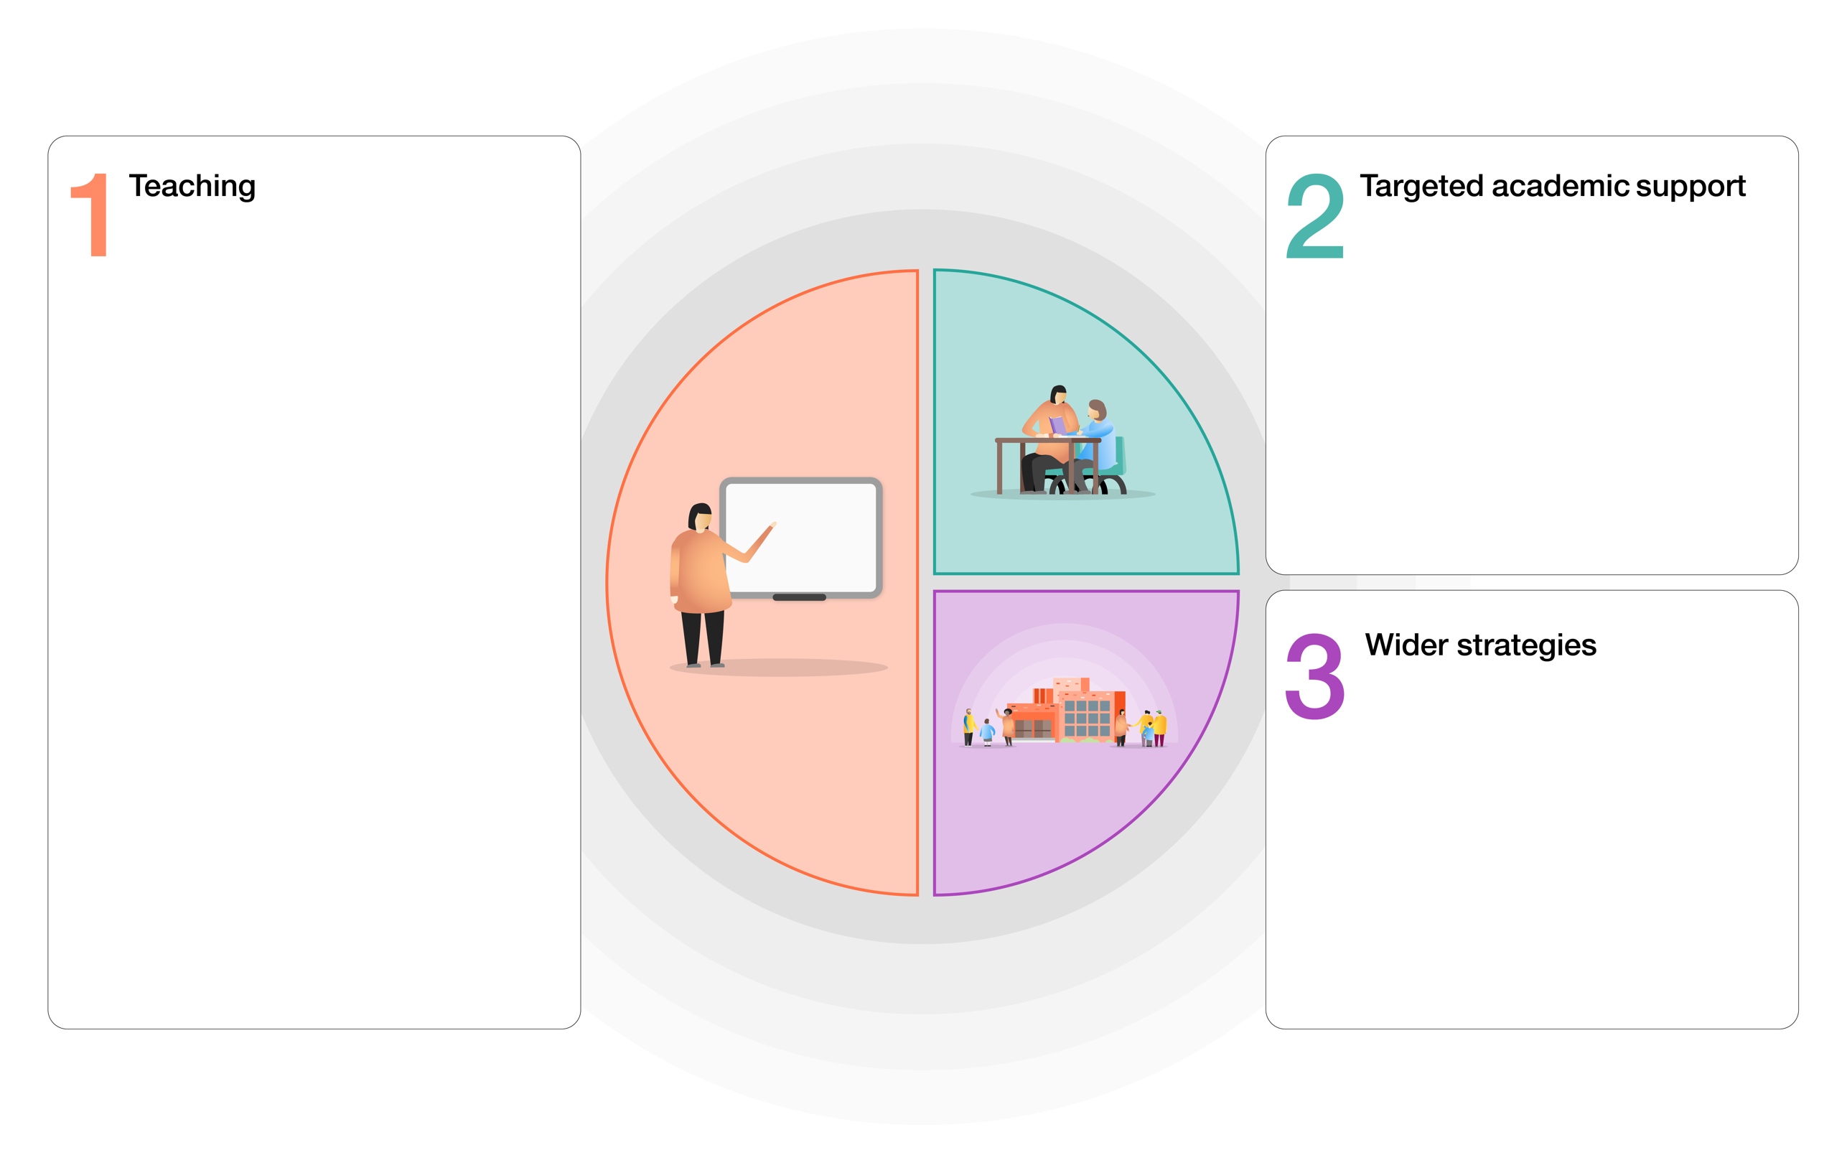

* Parent support advisor for families.
* Supported places for wraparound care club including free breakfast & positive social experiences.
* TIS Nurture provision (both group / 1:1)
* Lego Therapy.
* Enhanced activities, trips and visits provision included places for camp.
* Wild Tribe / outdoor learning.
* Teacher enrichment clubs.
* Music tuition support.
* Free milk
* Teacher / HLTA / TA led interventions including RWI phonics / reading / writing, maths mastery, pre teach, precision teaching, memory building and Fun Fit. Guided reading / writing groups.
* Use of ICT based resources; Spelling Shed, Sumdog, Times Tables Rockstars, Wordshark, Pobble, Numbots, Purple Mash
* Whole school TIS approach for emotional support.
* Whole school implementation of wellbeing in learning / extending creative learning outdoors.
* Reading for pleasure whole school approach. Purchase of Accelerated Reader to ensure breadth of genres covered and comprehension.
* Adoption of whole school teaching approaches- RWI phonics / reading / writing. Let’s think in English, Alan Peat sentence building, Pobble,
* Training in RWI, Mastery approach for Maths – working with Maths Hub to develop.
* EYFS projects with NELI (language development) and Maths Hub.
* Creative and pupil enquiry led approach to curriculum planning.
* Use of school based and homework resources – Sumdog, Spelling Shed, Times Tables Rockstars, Pobble, Purple Mash, Numbots
* Positive behaviour strategies to improve concentration, behaviour for learning and progress.

**PUPIL PREMIUM TIERED MODEL**

Grampound with Creed C of E Primary School