The Wild Tribe Achievement Award

For Primary School Children

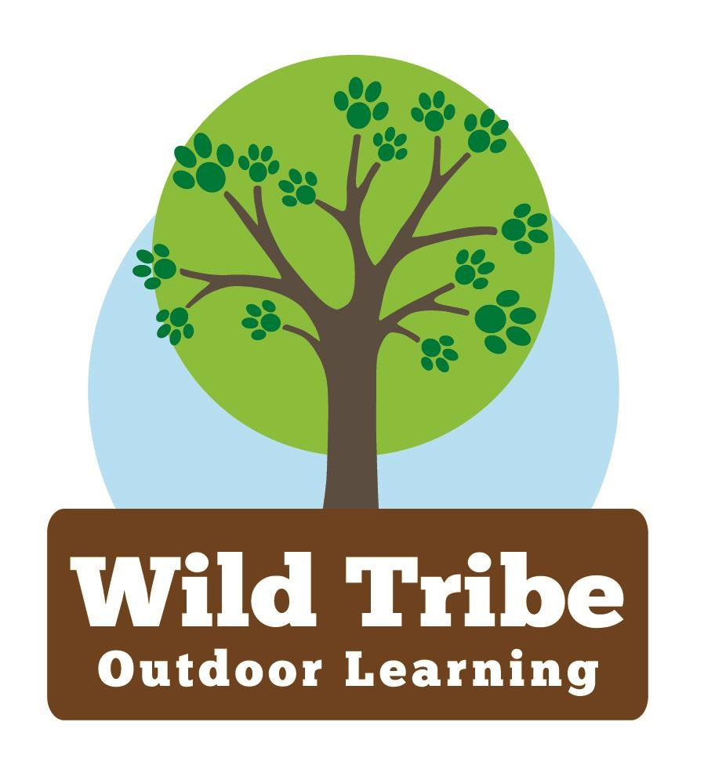

Fun, innovative challenges to complete
incorporating health and wellbeing, volunteering
and leading, life skills and respecting and enjoying
nature.

Bronze, Silver and Gold Levels

The ARENA Wild Tribe Award Scheme

Aim
The aim of this award is for you to learn, try new experiences, have fun, build self-confidence, be resilient, work with and help others to appreciate nature through a series of tasks and challenges. Some are quite easy and straightforward, others will require determination, resilience, courage and perseverance. Some will be completed at school, others maybe, at home.

The award is divided into 3 levels, Bronze (Pedrevan Class), Silver (Lostledan Class) and Gold (Kwilkyn Class) and within each level there are 4 strands:

- Health and Wellbeing – to enable you to be happy, safe and healthy.
- Volunteering and Leading – to develop a sense of personal power and to understand how volunteering can help others in your school and community.
- Life Skills – skills that are needed throughout life such as riding a bike, lighting a fire, cooking.
- Respecting and Enjoying the Natural Environment- learning how to appreciate nature and all that it offers.

Depending on the level, you need to complete a certain number of challenges in each strand which must be initialed and dated by an adult. For Bronze - 3, Silver - 5 and Gold - 7. There is also one final Adventure Challenge at each level that you MUST complete to gain the award.

On completion of an award, you will receive a bronze, silver or gold medal!
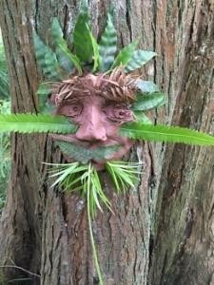

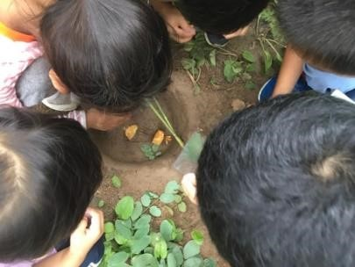

Bronze Level
Complete three activities from each of the four categories. If you have your own ideas, the final row has been left blank for you to add in your own activity. Then, take part in the Greta Thunberg Adventure Challenge to complete the Bronze Award.

Health & Wellbeing
 | Activity | Initial | Date
1. | Healthy eating: Make a fruit kebab.
2. | Physical activity: Go on a nature walk.
3. | Sport: Take part in a six-station fitness circuit using a variety of activities, for example, jumping jacks, shuttle runs.
4. | Survival: With a friend, make a feeder for the birds or an insect home.
5. | Wellbeing: Splash in a stream.

Volunteering & Leading
 | Activity | Initial | Date
1. | School: Carry out ‘special helper’ responsibilities in class.
2. | PE: Be a group leader or demonstrate a skill to the class.
3. | Leadership: Organise a game for some friends to play.
4. | Community: Take part in a litter pick.
5. | Volunteer: Offer to water plants, tidy up, help a friend etc.

Life Skills
 | Activity | Initial | Date
1. | First Aid: Learn how to make an emergency call.
2. | Cooking: Bake own bread roll.
3. | Bike: Balance or ride your bike (balance or pedals) around the playground.
4. | Pets: Clean out and feed a pet.
5. | DIY: Use tools to make something out of wood.

Respecting & Enjoying the Natural Environment
 | Activity | Initial | Date
1. | Senses: Explore nature through hearing, touch and smell.
2. | ID: Identify 4 plants and 4 flowers.
3. | Journey: Take your teddy on a teddy bear’s picnic.
4. | Make: Create some wild art, Andy Goldsworthy style, using natural materials (beach art).
5. | Fire: With supervision, help to build, light, manage and put out a fire.

The Greta Thunberg Adventure Challenge
Greta Thunberg has realised, ‘…that no one is too small to make a difference.’ Your Bronze challenge is to visit a wild place and do something to make it better, for example, a beach clean or tree planting.

Signed | Dated
Draw a picture, write a sentence or share a photo of what you did below. As a class, upload a video or photos of the challenge to your school platform.

Silver Level
Complete five activities from each of the four categories. If you have your own ideas, the final row has been left blank for you to add in your own activity. Then, take part in the Steve Backshall Adventure Challenge to complete the Silver Award.

Health & Wellbeing
 | Activity | Initial | Date
1. | Healthy eating: Design and make a healthy snack.
2. | Healthy eating: Eat something you have grown from seed.
3. | Physical activity: Go on a bat night walk with an adult.
4. | Sport: Take part in regular exercise, for example, dance or running.
5. | Survival: Climb a tree safely, enjoy the view and downclimb!
6. | Wellbeing: Watch and listen to the rain.
7. | Wellbeing: Sit by the sea and listen.

Volunteering & Leading
 | Activity | Initial | Date
1. | School: Take on a ‘Class Monitor’ role.
2. | PE: Ask to organise and lead a warm-up for a PE lesson.
3. | Leadership: Teach a friend a new game.
4. | Leadership: Organise and lead a game for younger children.
5. | Volunteer: Help at home on a regular basis, for example, sweep the garden path, for a fortnight (with the idea to keep going after the challenge is complete!).
6. | Volunteer: Do a ‘good deed’ for someone in need, for example, make some biscuits and deliver them to people in the community.
7. | Community: Take part in an organised beach clean/ litter pick.

Life Skills
 | Activity | Initial | Date
1. | First Aid: Know how to treat a bump, bruise or graze.
2. | Cooking: Help a grown up to prepare dinner.
3. | Bike: Take part in Bikeability Level 1 or the Learn 2 Ride programme or similar.
4. | Lifesaving: With a grown up, paddle or swim in the sea/river, thinking about safety.
5. | Outdoor: Using a simple map, learn how to orientate your map.
4. | Typing & IT: Learn the six keys above the home row.  Practice typing using the home and above home row.  Find out who Steve Backshall is using the internet.
5. | Organisation: Keep your bedroom tidy every day for a week.
6. | Independence: Go on a sleep over and pack what you need independently.
7. | DIY: With supervision, use a knife safely, for example, whittling wood (Wildtribe sessions)

Respecting & Enjoying the Natural Environment
 | Activity | Initial | Date
1. | Senses: Listen to and identify the sounds of nature. Write and perform a poem to others that describes these sounds.
2. | ID: Identify at least 2 insects you have never seen before.
3. | Journey: Do a wildlife watch, for example, study wildlife at school during daylight hours.
4. | Journey: Go barefoot on the school field (check the ground beforehand).
5. | Make: With supervision, use at least 2 tools, for example, hammer or drill, to make something from wood (Wildtribe sessions)
6. | Create: Make a trail outdoors for others to follow.
7. | Fire: With supervision, cook something on an outdoor fire that you have made, for example, pizza or bread.  (Wildtribe sessions)

The Steve Backshall Adventure Challenge
The naturalist and explorer, Steve Backshall has said, ‘It's really important that we know we can change this planet for the better and that every single one of us, no matter how small we may feel, has that power.’ Your Silver challenge is to plan and prepare a challenging walk, run or bike ride with school or family. During this adventure, keep a record of what you might do to help our planet. Take one of the ideas you list and act on it during your challenge or as soon as possible afterwards.

Signed | Dated

Draw a picture, write a sentence or share a photo of what you did below. As a class, upload a video or photos of the challenge to your school platform.

Gold Level
Complete seven activities from each of the four categories. If you have your own ideas, the final row has been left blank for you to add in your own activity. Then, take part in the David Attenborough Adventure Challenge to complete the Gold Award.

Health & Wellbeing
 | Activity | Initial | Date
1. | Healthy eating: Plant, grow and care for an edible plant that you can use when cooking on an open fire (cooking done in Wildtribe sessions)
2. | Physical activity: Look at a map of your local area. Find the highest spot you can walk to and back for your adventure. Climb the spot and appreciate the view!
3. | Physical activity: Take part in a new outdoor activity that you have not experienced before, for example, climbing or canoeing.
5. | Sport: Try a new sport.
6. | Survival: Make a shelter using natural materials  (Wildtribe sessions)
7. | Survival: Learn simple sewing and repair something.
8. | Wellbeing: Choose an outdoor location you can visit on a weekly basis. Take a photo of yourself in that location throughout the seasons. Make a collage of the seasons.

Volunteering & Leading
 | Activity | Initial | Date
1. | School: Become a good role model in school by being an active member of the school or sports council or in another aspect of school life.
2. | School: Take the opportunity to support organising and volunteering at a school event.
3. | PE: Ask and plan to lead the warm-up and cool down in a PE lesson.
4. | Leadership: Support a local charity.
5. | Leadership: Take part in a ‘leadership’ award such as playground leaders, outdoor leaders or the John Muir award.
7. | Volunteer: Read stories to younger children.
9. | Volunteer: Do a weekly good deed/ errand for someone in need (home, school or community) on a regular basis for a month or more, for example, bake cakes, go to the local shops, take out their recycling/rubbish.

Life Skills
 | Activity | Initial | Date
1. | First Aid: Know how to treat a broken bone, how to make an improvised stretcher and use in a scenario.
2. | Cooking: Read a recipe and prepare a simple meal.
3. | Bike: Take part in Bikeability Level 1 or 2.
4. | Lifesaving: Learn the Beach Safety rules.
5. | Outdoor: Read and navigate using an OS map.
6. | Typing & IT. Learn the keys below the home row. Use your typing and IT skills to find out about and write a paragraph about David Attenborough.
8. | Independence: Build, light, manage and put out a fire safely (Wildtribe sessions)

Respecting & Enjoying the Natural Environment
 | Activity | Initial | Date
1. | Senses: Learn and understand the Countryside Code.
2. | ID: Identify plants and trees on the school site or in your garden (Wildtribe sessions)
3. | ID: Explore and identify the contents of a pond or rock pool.
5. | Journey: Go on a challenging walk using an OS map and carrying everything you need in a rucksack.
6. | Make: Perform a play or story outside with friends using puppets or yourself.
7. | Make: Write a story set in the outdoors accompanied by art in the form of photos / drawings / nature pictures.
9. | Fire: Cook your food on a fire (Wildtribe sessions)

The David Attenborough Adventure Challenge
In the spirit of Sir David Attenborough, your Gold challenge is to survive for twenty-four hours in the outdoors, with adult supervision, using a tent or shelter you have pitched or built. Cook your food on a stove or fire having created your own menu. Make a nature diary of your Challenge and make your own presentation of how you will ‘work with nature not against it’ (Attenborough). You can present this in words, pictures, song, poem, dance or theatre!

Signed | Dated

Draw a picture, write a sentence or share a photo of the idea that you presented below. Upload a class video or photos showing some of the ideas of the challenge to your school platform.

