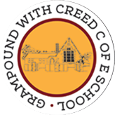
Grampound with Creed School - EYFS – Knowledge Organiser

 |  |  |  |  |  | Who Lives in a Rock Pool?
 | Key Vocabulary |  |  |  |  | Key Learning  - Our planet is called the Blue Planet because it is mostly water  - Marine animals live in different zones in the ocean  - Some marine animals hunt prey  - Some marine animals move around together in a shoal  - The sea shore is where the ocean meets the land  - The sea comes in and out and is call the tide  - Rock pools are created when the tide goes out  - Some creatures live in rock pools all the time, others change with the tide  - Starfish, crabs and lobsters have exoskeletons  - Jellyfish have no bones  - Some creatures in rock pools can sting, pinch and bite  - You must be careful near a rock pool as seaweed can be slippery and barnacles are sharp  - Rubbish can end up in the sea and harm sea life  - We can help by putting rubbish in the bin or recycling
 | Tier 1  Ocean  Sea shore  Tide  Rock pool  Starfish  Jellyfish  Crab  Anemone  Seaweed  Barnacles  Limpet  Mussel  Shell  Pebble  Sand  Coral reef | Tier 2  Pinch  Bite  Sting  Harmful  Recycle  Dive  Breach  Shallow  Deep  Hunt | Tier 3  Marine  Exo skeleton  Pollution  Abyss  Prey  Shoal
 | Key Texts  *The Rainbow Fish  *Tiddler |  |  |  |  | Key songs/rhymes  *Down in the ocean  *1,2,3,4,5 once I caught a fish alive |  | Online resources  *You Tube videos of marine creatures
 |  |  |  |  |  | Key Themes
 | Life in a rock pool |  |  |  |  |  | Marine Animals |  | Looking after our oceans
 | 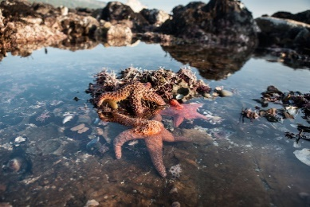 |  |  |  |  | 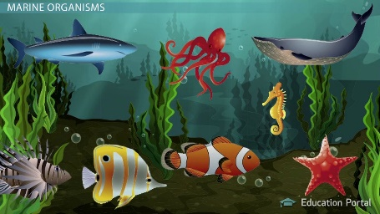 |  | 