**Kwilkyn Class**

**The Second World War**

**Essential Knowledge**

By the end of this unit …

* Children will understand how WW2 came about and how life changed after 1930, in Britain.
* Children will gain a better understanding of what it would have been like to be a child during WW2 and to look at the differences between then and now.
* Children will gather evidence to see how life has changed since WW2 and look at the ways in which people lived through this time.
* Children will understand who was on each side during the war and be able to place key events onto a time line.
* Children will understand why health and nutrition were important during WW2 and the ways in which the country ensured this was upheld during difficult times. Looking at ways of preserving foods and making the most with what they had.
* Children will be able to wrote from the perspective of a child during this time.
* Children will look at how to create a healthy meal using rationing.

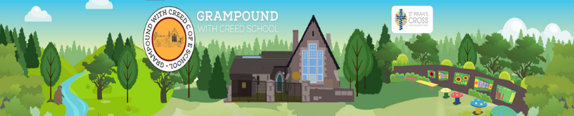

**Launch**

Workshops based on the Home Front during WW2.

**Explore**

Children to understand what life would have been like as a child during WW2. Looking at daily life, evacuation and rationing.

**Energise**

Visits to help the children bring to life the things they have learnt so far.

**Celebrate**

A WW2 style Christmas celebration.

Food, decorations and presents created in the way in which they would have been done during the war.



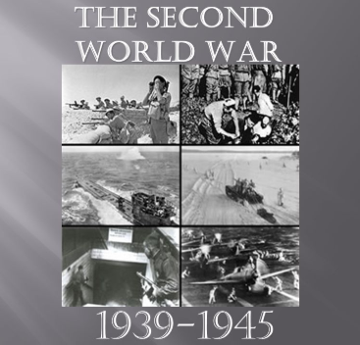



**Moral**

* To understand why WW2 started and to discuss how this would have people feel. Linking with the Jewish people across Europe. How did people help?

**Science**

* Exercise and healthy exercise. A look at the effects of exercise on the human body and the amount needed keep healthy.
* Nutrition and healthy eating. What does the body need to survive?
* Microorganisms. During the war it was hard to keep food fresh. A look at what happens when food goes bad and ways they dealt with at the time.
* Forces – Buoyancy – A look at how submarines work and their effects during the war.

**Mathematics**

* Co-ordinates – Battleships
* Rationing problems
* Conversion of weights.

**Music / Languages**

* Listen to and perform songs from 1940’s Britain.
* Write our own song to boost morale and perform.
* Spanish

**Art and Design / Design Technology**

* Design and make an air raid shelter.
* Propaganda posters
* Study famous war paintings. Look at how these are done and create our own. Blitz Pictures.
* Cooking – create recipes from WW2 using rationing. Preserve fruits – make jam.
* Make do and mend – knitting/sewing.

**Character**

* Perseverance – How people kept going throughout the war.

**History / Geography**

* Find out where children were evacuated to in England. Show on a map and explain why these places were chosen
* Create a map of Europe/The World showing the Axis and Allies involved in the war.
* To understand why the war started and to order key events.
* To understand what it was like to be a child during WW2. A look at the homefront, including evacuation, rationing, The Blitz.
* Children to research what daily life was like for people/children in Britain. School, clothes, food, entertainment (music /dancing), staying safe.

**Physical Education/Computing**

* Research information using the internet.
* Gymnastics
* Team games.

**Cultural**

* Why people served their country and the pride that that bought to them. Not just soldiers but people on the home front providing food etc.

**Social**

* Respect/compassion – How people supported each other, evacuees, host families, Jewish people, soldiers.

**Spiritual**

* Understanding Judaism and their beliefs.

**English**

* Read stories linked to evacuation. Write stories linked to these using ideas from the books.
* Write letters home based real evacuation letters. Use language/phrases of the time.
* Create poetry based on what they have learnt about the war.
* Drama and Role based on what we read and learn about WW2..

**The Second World War - Theme Content**

**Core Subjects**

**Personal Development**

**Foundation Subjects.**