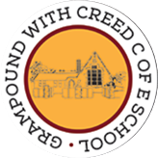
Grampound with Creed School - EYFS – Knowledge Organiser
 |  |  |  |  |  | Birthdays
 | Key Vocabulary |  |  |  |  | Key Learning  - A birthday is a celebration of the day you were born.  - Every year on your birthday, you get another year older.  - Each year we change and grow older and can do new things!  - The number of candles on a cake represents how old you are on your birthday.  - Birthdays are celebrated in many ways, often with; parties, food, music, dancing and games.  - It is a tradition to give presents and cards to a person on their birthday.
 | Tier 1  Years ago  Next year  Yesterday  Today  Tomorrow  Party  Balloons  Cake  Candles  Decorations  Music  Dancing  Friends Baby | Tier 2  Invitations  Celebrate Special  Tradition Represent  Born Older  Growing  Changing  Toddler  Adult | Tier 3
 | Key Texts  Kipper’s Birthday by Mick Inkpen |  |  |  |  | Key songs/rhymes  - Happy Birthday – traditional song | Online resources  - Cbeebies/watch/something-special-happy-birthday  - Cbeebies Topsy and Tim – “Birthday Party”  - Peppa Pig – “My birthday Party” - YouTube
 |  |  |  |  |  | Key Themes
 |  |  |  |  |  | Birthday celebrations |  | Growing, changing and getting older
 |  |  |  |  |  | 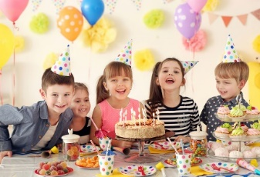 |  | 