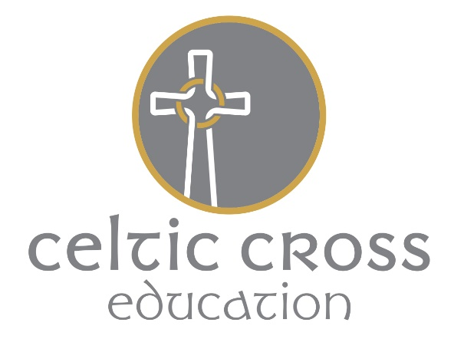

Pupil Premium

Grampound with Creed is an active and happy Church of England primary school which aims to develop each individual in a caring, family atmosphere. The children, staff and parents are extremely proud of our school and we aim to be inclusive of all children whatever needs they may have.

Our School is part of a Multi Academy Trust. The Trust brings together twelve church schools in a collaborative way, to share, learn from and support each other to benefit the pupils of all the schools.
Managed centrally, the trust will provide school improvement opportunities, financial stability and a family network of schools that, under the common synergy of a Christian based learning environment, will provide high quality education in rural Cornwall.
We want all of our pupils and staff to succeed and our promise is to try our best to give each and every pupil that opportunity to achieve and to reach their full potential.
The targeted and strategic use of Pupil Premium funding will support us in achieving our aims and principles.
Aims and Principles
Grampound with Creed School is committed to ‘Narrowing the Gap’ between vulnerable pupils and those judged not vulnerable; the Pupil Premium forms a vital part of that process. The governors reserve the right to allocate the Pupil Premium funding to support any pupils or groups of pupils the school has legitimately identified as being socially disadvantaged.
- We ensure that teaching and learning opportunities meet the needs of all pupils.
- We ensure that appropriate provision is made for pupils who belong to vulnerable groups. This specifically includes ensuring that the needs of socially disadvantaged pupils are addressed.
- In making provision for socially disadvantaged pupils, we recognise that not all pupils who are eligible for free school meals, (or have been eligible in the last 6 years) are socially disadvantaged.
- We also recognise that not all pupils who are socially disadvantaged are registered or qualify for free school meals. We therefore allocate Pupil Premium funding to support any pupil or groups of pupils that the school has legitimately identified as being socially disadvantaged.
Pupil Premium funding will be allocated and amended following termly needs analyses which will identify priority groups and individuals. Termly tracking meetings will monitor the impact of targeted support for identified pupils. Children who are entitled to receive Pupil Premium funding are: children in receipt of free school meals currently or in the past, looked after children and children whose parent(s) are in the forces.
Provision
Provision will be made through:

- Facilitating pupils’ access to education
- Facilitating pupils’ access to the curriculum
- Alternative support and intervention within the school
We have a range of provision in place to support children who belong to vulnerable groups, including those who are socially disadvantaged. This provision has the full support of the Governing Body and includes:
- Targeted interventions aimed at accelerating learning which may include maths and literacy
- Additional support for social and emotional needs that may be a barrier to narrowing the gap
- When necessary, to provide one-to-one tuition for some pupils
- To support the cost of employing additional staff to support vulnerable families through Parent Support Advisors, and therefore overcome potential barriers to learning
- To support the funding towards school trips and visits
- To support the funding of enrichment activities / wraparound care
- To provide additional resources to support learning where appropriate
- To support children’s learning in the classroom by ensuring that all children who qualify for Pupil Premium have their needs clearly identified and their progress is closely monitored.
All our work funded by the Pupil Premium will be aimed at accelerating progress so that the vast majority of children leave our school at, or above, the National average. We also aim for every child to make progress that is good or better. Funding will also be used to develop high aspirations for the future so that children can continue to succeed.
Reporting
It is the responsibility of the governors to explain pupil premium expenditure to parents in the form of an annual statement. Our school will publish details of a report online annually. This report aims to detail information on how Pupil Premium has been used within school. Parents will be able to obtain information on the pupil premium through this report which will be available via the schools website.
The Head of School and SENCO (Special Educational Needs Coordinator) will report to a named link Governor every term who in turn will report termly to the Governing Body
- the progress made towards narrowing the gap, by year group, for socially disadvantaged pupils
- an outline of the provision
- an evaluation of the cost effectiveness, in terms of the progress made by the pupils receiving a particular provision, when compared with other forms of support
The Governors of the school will ensure that there is an annual statement to parents and carers on how the Pupil Premium funding has been used to address the issue of ‘narrowing the gap’, for socially disadvantaged pupils. This statement will be published on the schools website.
Appeal
Any appeals against this policy will be through the SMC’ complaints procedure.
Any enquiries should be made to: Head of School or SENCO tel: 01726 882644
This policy was approved by the Local SMC in March 2017.
This policy was reviewed in December 2019 – no change

