Marking and Feedback Policy

September 2019

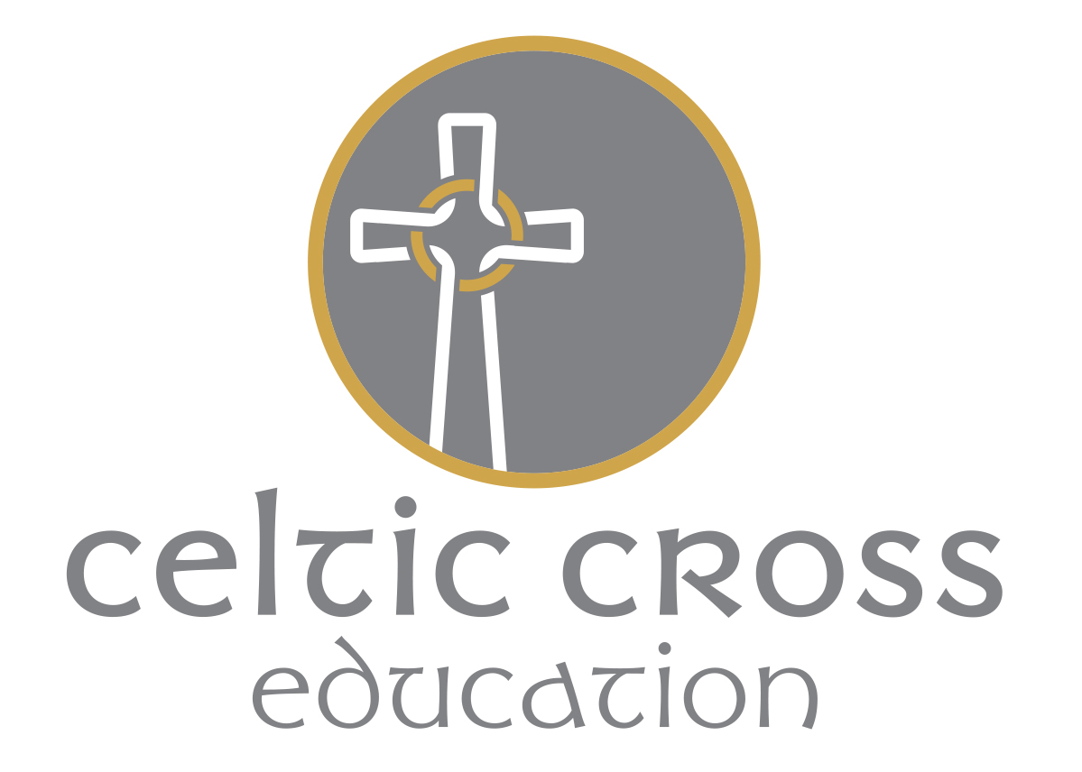

Purpose of marking and feedback

- To engage with the detail of children’s work so they know how well they are doing, where they need to improve and how this might have a bearing on subsequent teaching
- To provide children with information about where they should improve and how to do it (Tom Sherrington, 2017)

Features of effective marking and feedback

- Selective: marking will be at the frequency and depth that children have the capacity to respond to – not everything needs to be marked
- Only mark work that will be returned to the children to improve or correct. Work will not be marked simply for presentational purposes
- Formative: written comments will be restricted to those that inform children how to improve or give instructions for actions they should take; otherwise symbols/codes will be used (see below)
- Marking should be seen as an instruction for what children will do
- Every time books are marked, children should be given time to respond to the comments and feedback immediately (Tom Sherrington, 2017)

Aims of marking and feedback

We aim to ensure that all children have their work marked in such a way that it will lead to improved learning, develop self-confidence, raise self-esteem and provide opportunities for assessment – including self-assessment. Marking should encourage the children to be aware of how and what they are learning.

Guidance for marking and feedback

- A green pen / highlighter should be used by staff
- Work marked by the children should be in purple. Children should be encouraged and trained to mark their own and other’s work where they highlight success and improvement
- In depth marking will be completed as appropriate (agreed at school level) in Maths and in English
- Regular and frequent written feedback will be given to children in an appropriate way for their age and ability. Any work that is distance marked should be written in child friendly language. Written feedback should model the school’s handwriting policy. All marking should be positive, informative and constructive
- Children should be encouraged to leave incorrect answers and not rub them out
- In English, spelling corrections should be limited to the words the child should know (common exception words must be picked up in all year groups) and a maximum of 3 spelling mistakes will be targeted. The teachers will then use a graded approach to tackling the spelling error.
(See approaches at end of policy)

Agreed Procedure

All children’s work will contain:

The Date

The WALT or LO (What the class are learning today or learning objective) where appropriate.

A single learning objective should be recorded for each activity. This should be in child speak and precise.
Success Criteria  (when appropriate)  What the child needs to do to be successful | Developing success criteria to achieve the learning objective helps provide pupils with a framework against which they can focus their efforts, evaluate their progress and discuss issues.  Success criteria can be generated by the teacher, but it has been recognised that where pupils together generate their own success criteria to meet a learning objective they gain more ownership over the learning with positive results.
Identification of learning groups

(I-Independent, HLTA, TA- Supported, T-Teacher, ST – Supply Teacher)

The date, title and WALT/learning objective should be included at the start of each piece of work. These can be handwritten by the child/adult or printed on slips or stickers as appropriate.

Handwriting and presentation

- Handwriting and presentation should follow the school’s policy and should be of a high standard. Books and learning over time should evidence work that children are really proud of.

- Letter and number reversals must be addressed if incorrect.

Other forms of feedback

Whole class feedback

Whole class feedback ensures children receive feedback more promptly which means it is likely to have more impact.

Staff take all the children’s books in and read through work that feedback is to be given on. Instead of making any marks in children’s books, the teacher make notes on a whole class feedback sheet (agreed at school level). This forms the basis of whole-class feedback and it might include:

*common technical errors and misconceptions

*common areas for improvement either in the substance of the work or in the presentation

*common spelling and grammatical errors

*particular books that demonstrate excellence to share with the whole class

*particular books that are below par and will need special attention

Ideally the following lesson, the books are given back out and the teacher runs through the comments. Children are given redrafting tasks to address common issues, check their spellings, search for common errors and make immediate improvements in books, using purple pen.

Live marking

Live marking (written or verbal) is a strategy which can be used to target a range of pupils in a particular lesson. During whole class teaching, teachers can assess work and give questions to pupils; which closes the gap in learning. Quick codes/symbols can be used to allow children to self and peer assess.
Marking and Feedback Symbols/Codes

There is no expectation that stickers have to be used for marking and feedback but can be used if appropriate to class.

English Feedback Symbols

Correct / Good example | _______
Handwriting | hw
Finger spaces | FS
Paragraph needed | //
Check the spelling | SP (in the margin)
Omission / Add something to improve here | ^
Incorrect or missing punctuation | P
Capital Letters | ABC
Check for sense | ?

Maths Feedback Symbols

Correct
Check through this answer | .

Approaches to correcting spellings include:

Live marking – use of phonic knowledge, dictionaries, word walls, flip charts, writing journals.
Response to marking – use of copying out mistakes 3x, using dictionaries or other to correct underlined words, adding mistakes to journals, spelling books or word walls etc.

