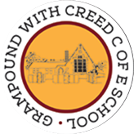
Grampound with Creed School - EYFS – Knowledge Organiser
 |  |  |  |  |  | Diwali
 | Key Vocabulary |  |  |  |  | Key Learning  - Every year in October/November, Hindus celebrate the festival of Diwali.  - Diwali is a celebration of good winning over evil in the story of Rama and Sita.  - Diwali is known as the festival of light.  - Light is important in the story as lights called Diva lamps were lit to help Rama and Sita find their way home.  - Hindus celebrate Diwali in many ways, and these have become traditions, for example: decorating the home with Diva lamps, lighting lanterns and fireworks, making Rangoli patterns outside the door to welcome visitors and the Goddess of Light Lakshmi, Mehndi patterns on arms and preparing special food such as coconut ladoo sweets.  - Some ways of celebrating are unique to Diwali, but others feature in many different celebrations, such as birthdays, bonfire night and Christmas.  - Hindus believe in several Gods, one of which is Hanuman the Monkey King in the story of Rama and Sita and one is Lakshmi, the Goddess of Light.
 | Tier 1  A long time ago  Now  Forest Jewellery  Gods Island  Arrow  Light/dark  King/Queen  Coconut Fireworks Good/evil | Tier 2  Lanterns  Demon  Goddess  Celebrate  Tradition  Festival | Tier 3  Diwali  Hindu  Rama and Sita  Lakshmi Mehndi  Hanuman Diva lamp  Ravana Rangoli  Ladoo
 | Key Texts  - Rama and Sita the story of Diwali  - Non-fiction books about Diwali |  |  |  |  | Key songs/rhymes  - I’m a Little Diva Lamp | Online resources  - Images of Diwali celebrations  - Twinkl E-Book – Dipal’s Diwali  - Twinkle PowerPoint – Rama and Sita story
 |  |  |  |  |  | Key Themes
 | The story of Rama and Sita |  |  |  |  | Diwali Celebrations |  | Hindu Gods
 | 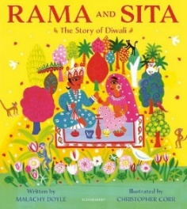 |  |  |  |  | 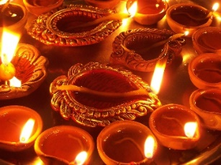 |  | 